**LEASE MANAGEMENT**

***College Name:*** *Navarasam Arts and Science College for Women.*

***College Code:***638 101.

***TEAM ID:*** *NM2025TMID27182*

**TEAM MEMBERS:-**

**Team Leader: NARMATHA D**

**Email:** [**td.narmatha@gmail.com**](mailto:td.narmatha@gmail.com)

**Team Member: SUBIKSHA R**

**Email:** [2005subiksha@gmail.com](mailto:2005subiksha@gmail.com)

**Team Member: BEULA M**

**Email:** [mbeulamurugesan@gmail.com](mailto:mbeulamurugesan@gmail.com)

**Team member: RUBAVARSHINI M**

**Email:** [varshuharry8@gmail.com](mailto:varshuharry8@gmail.com)

Title: Lease Management using Salesforce

**Project Overview**: Lease Management Using Salesforce

The Lease Management System on Salesforce is designed to streamline and automate the end-to-end process of managing leases for properties, equipment, or vehicles. Traditionally, lease management involves manual processes such as contract creation, tenant onboarding, rent collection, renewal tracking, and compliance management. By leveraging Salesforce, organizations can centralize lease-related data, automate workflows, improve customer/tenant engagement, and ensure compliance with accounting standards.This system can be built using Salesforce Sales Cloud, Service Cloud, Experience Cloud, and custom objects for leases, properties, payments, and contracts. Additionally, automation tools (Flows, Process Builder, Approval Processes) and reporting dashboards provide real-time insights.

**Project Objectives:-**

*1. Centralized Lease Repository*

* Store all lease agreements, tenant/lessor details, property information, and financial terms in Salesforce.
* Enable easy retrieval of lease documents and history.

*2.Automated Lease Lifecycle Management*

* Automate workflows for lease creation, approvals, renewals, and termination.
* Track key dates (e.g., payment due dates, renewal deadlines, compliance reviews).

*3.Payment & Billing Management*

* Integrate payment schedules, rent invoicing, and collections within Salesforce.
* Enable automated reminders for overdue payments and reconciliation with accounting systems.

*4.Compliance & Risk Management*

* Ensure leases adhere to financial reporting standards (e.g., IFRS 16, ASC 842).
* Track insurance, regulatory, and compliance requirements.

*5.Improved Tenant & Lessor Engagement*

* Use Experience Cloud portals for tenants/lessors to view agreements, pay rent, and raise service requests.
* Provide customer service case management for maintenance and support requests.

*6.Real-Time Analytics & Reporting*

* Provide dashboards for occupancy rates, revenue forecasting, payment status, and lease expirations.
* Enable leadership to make data-driven decisions.

*7.Integra tion with External Systems*

* Connect with ERP/Accounting systems (SAP, Oracle, QuickBooks) for financial reporting.
* Integrate with e-signature tools (DocuSign, Adobe Sign) for digital contract execution.

**Student Outcomes :-**

*1.Understand Lease Processes* – Learn the business flow of leasing (contract creation, rent tracking, renewals, terminations).

*2.Apply Salesforce Concepts* – Gain hands-on experience with Salesforce objects, automation, reports, and dashboards.

*3.Design Data Models* – Create custom objects and relationships (e.g., Lease, Property, Tenant, Payment).

4.Implement Automation – Use Flows, Validation Rules, and Approval Processes to streamline operations.

*5.Enhance User Experience* – Customize Lightning pages and Experience Cloud for tenants/landlords.

*6.Generate Insights* – Build reports & dashboards for occupancy rates, rent due, and renewal trends.

*7.Real-World Application* – Demonstrate how Salesforce can replace manual lease management systems with cloud-based automation.

**System Requirements**:-

**Hardware Requirements:**

* Computer with 4GB RAM,Dual core processor.
* Stable Internet Connection.

**Software Requirements:**

* Salesforce Developer Edition Org.
* Web Browers like GoogleChrome, Firefox, Microsoft Edge

Milestone 1:Salesforce Account Creation

Activity 1:Creating Developer Account

Creating a developer org in salesforce.

1. Go to <https://developer.salesforce.com/signup>

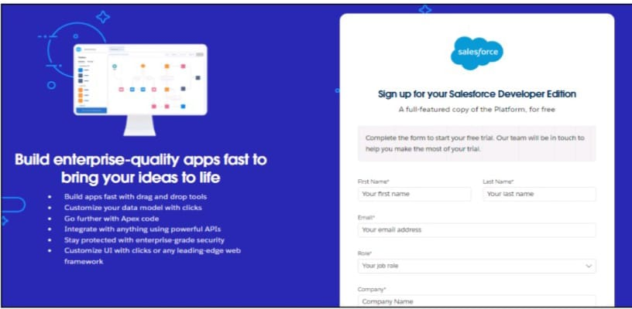

2.This above is the form appears when we touch the link.

The above Requirements are

1. First name & Last name
2. Email
3. Role : Developer
4. Company : College Name
5. County : India
6. Postal Code : pin code
7. Username : should be a combination of your name and company

This need not be an actual email id, you can give anything in the format : username@organization.com

Click on sign me up after filling these.

***Activity 2:Account Activation***

1. Go to the inbox of the email that you used while signing up. Click on the verify account to activate your account. The email may take 5-10mins.

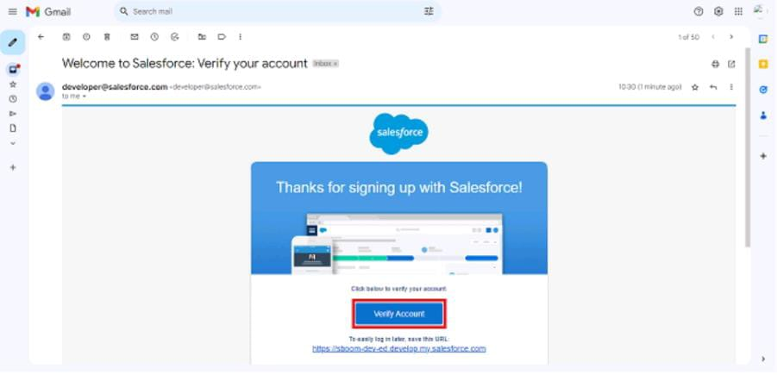

2.After clicking the verify Account it changed into a Change Password Screen

* Give a Password and answer aSecurity Questions.
* New Password and Confirm Password text box should be Match.
* After clicking Change Password you will be redirect to your salesforce setup page.

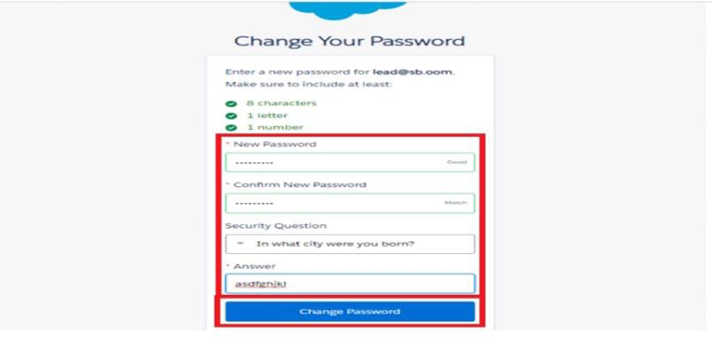

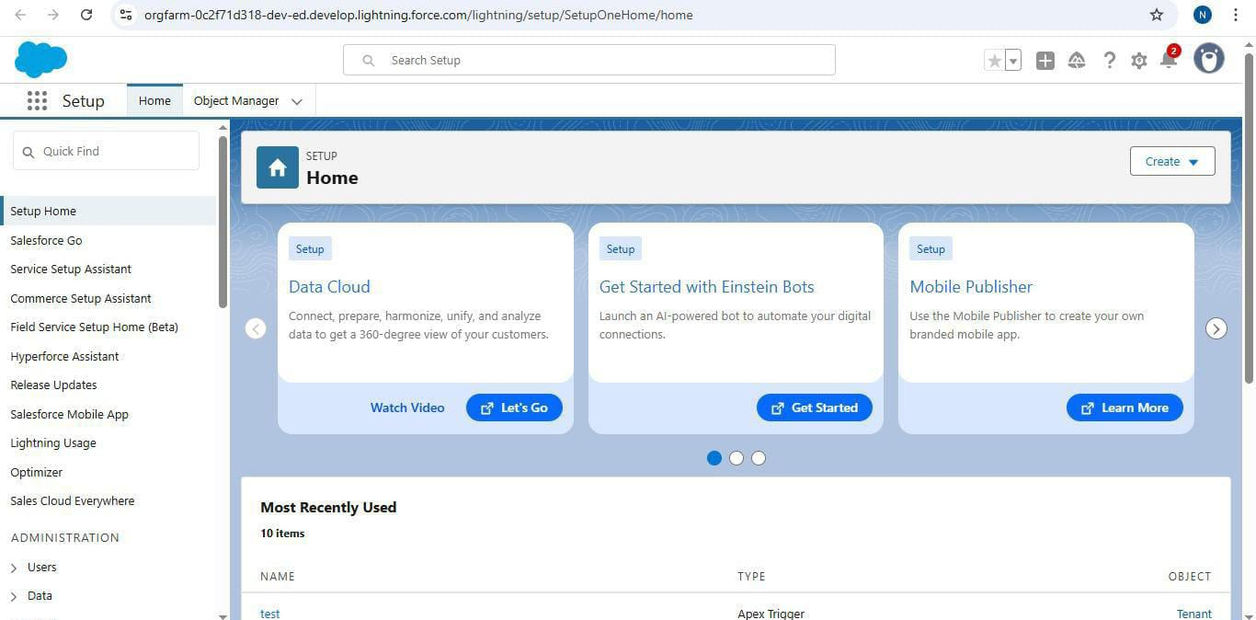

**Milestone 2:Object**

What Is an Object?

Salesforce objects are database tables that permit you to store data that is specific to an organization.Types of Salesforce Objects:

* Salesforce Objects
* Custom Objects

To Navigate to Setup page:

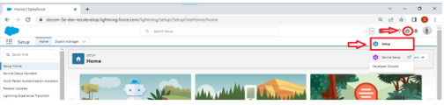

1. From the setup page >> Click on Object Manager >> Click on Create >> Click on Custom Object.

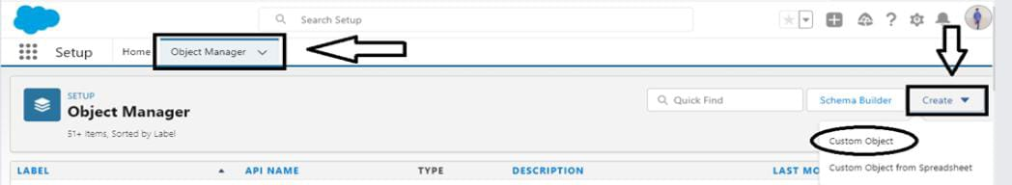

2.On Custom object defining page:

3.Enter the label name, plural label name, click on Allow reports, Allow search.

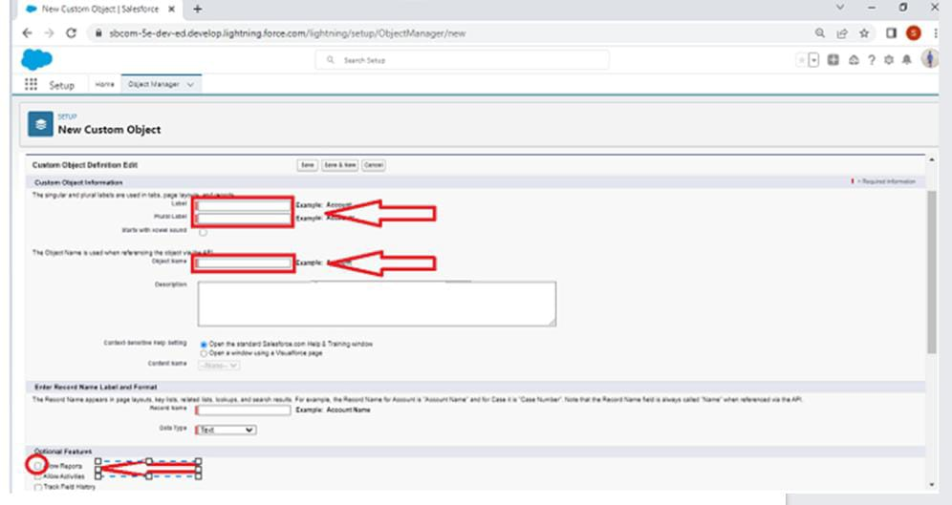

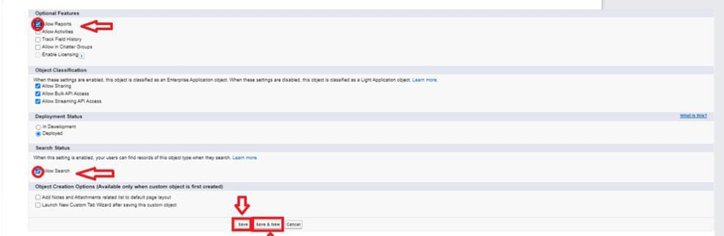

4.Then Click on Save.

***Activity 1:Create Property Object:-***

Create an Object:

* From the Setup Page. Click on the Object Manager it will have Click on Create button, just click on it .
* From the Drop down select Custom Object
* Enter the label name as property and Plural label name as property.
* In the Record Name and Label Format enter

1. Record Name>>property Name

2. Data Type>>Text.

* Then Click on Allow reports , Track Field History, Allow Activities, Allow Search
* Finally Click on Save.

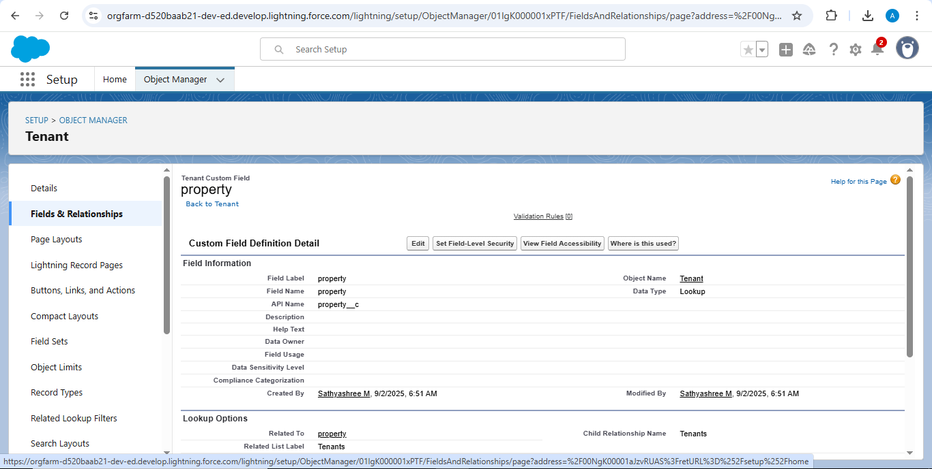

***Activity 2:Create Tenant Object:-***

* From the Setup Page. Click on the Object Manager it will have Click on Create button, just click on it .
* From the Drop down select Custom Object
* Enter the label name as Tenant and Plural label name as Tenants
* In the Record Name and Label Format enter

1. Record Name>> Tenant Name

2. Data Type>>Text

* Then Click on Allow reports , Track Field History, Allow Activities, Allow Search
* Finally Click on Save.

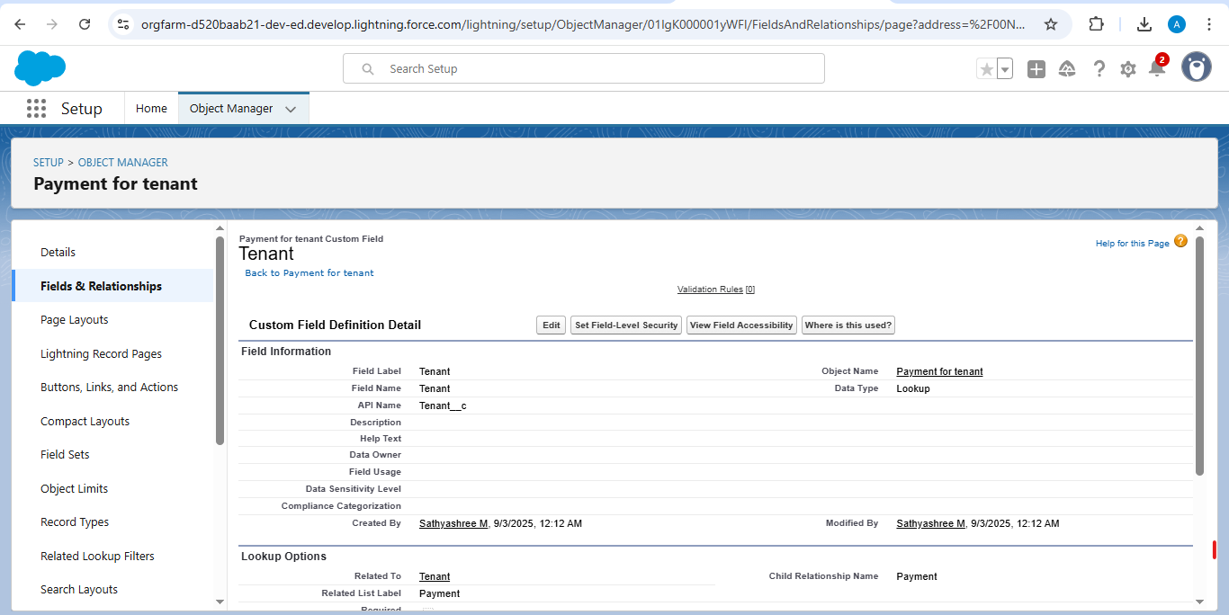

***Activity3:Create Payment Object:-***

* From the Setup Page. Click on the Object Manager it will have Click on Create button, just click on it .
* From the Drop down select Custom Object
* Enter the label name as Payment for tenant and Plural label name as Payment
* In the Record Name and Label Format enter

1. Record Name>> Payment Name

2. Data Type>>Text

* Then Click on Allow reports , Track Field History, Allow Activities, Allow Search
* Finally Click on Save.

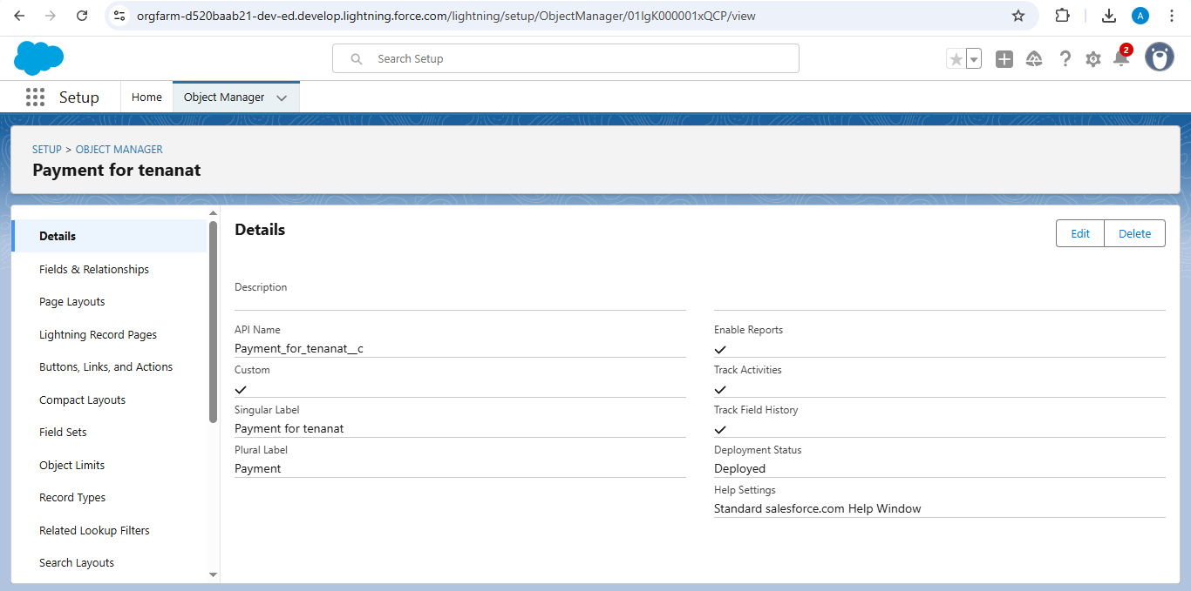

***Activity4:Create Lease Object:-***

* From the Setup Page. Click on the Object Manager it will have Click on Create button, just click on it .
* From the Drop down select Custom Object
* Enter the label name as lease and Plural label name as lease
* In the Record Name and Label Format enter

1. Record Name>> lease Name

2. Data Type>>Text

* Then Click on Allow reports , Track Field History, Allow Activities, Allow Search
* Finally Click on Save.

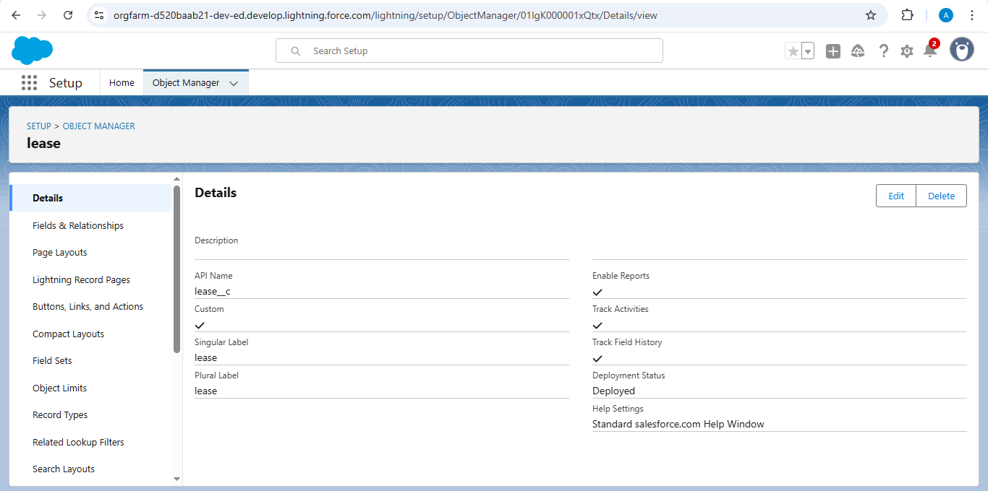

**Milestone 3:Tabs**

What is Tab: A tab is like a user interface that is used to build records for objects and to view the records in the objects.

Types of Tabs:

* Custom Tabs
* Web Tabs

1. Visualforce Tabs
2. Lightning Component Tabs

3.Lightning Page Tabs

***Activity1:Creating a Custom Tab:-***

To create a Tab:( Property)

1. Go to setup page >>type Tabs in Quick Find bar >> click on tabs >> New (under custom object tab)
2. Select Object(property), select the tab style you want and click next (keep the page as default) and then click next uncheck the include tab in Add to Custom App Page
3. Make sure that the Append tab to users’ existing personal customization is checked.
4. Click Save.

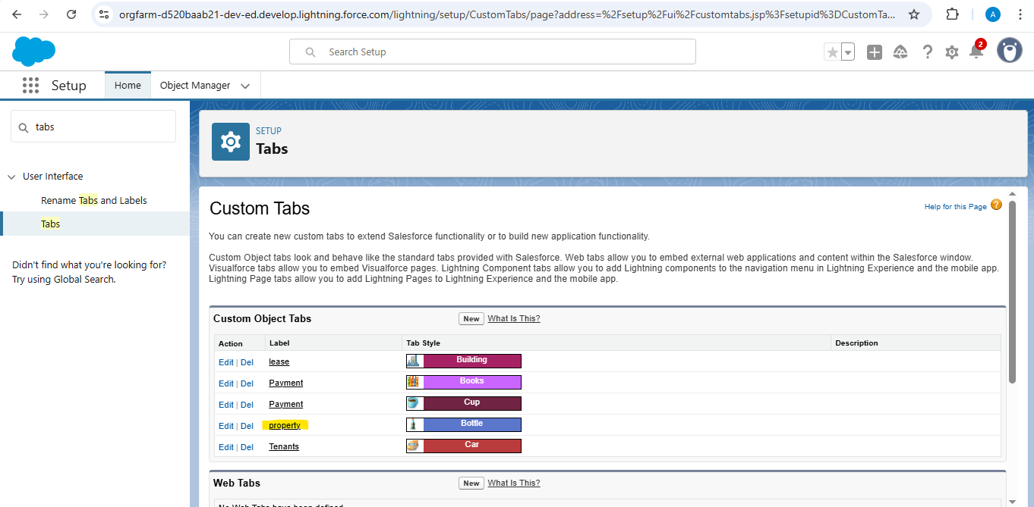

***Activity2:Creating Remaining Tabs:-***

Payment for Tenant:

To create a Tab:( Payment for tenant)

1. Go to setup page >>type Tabs in Quick Find bar >> click on tabs >> New (under custom object tab)
2. Select Object(Payment for tenant), select the tab style you want and click next (keep the page as default) and then click next uncheck the include tab in Add to Custom App Page

3.Make sure that the Append tab to users’ existing personal customization is checked.

Click Save

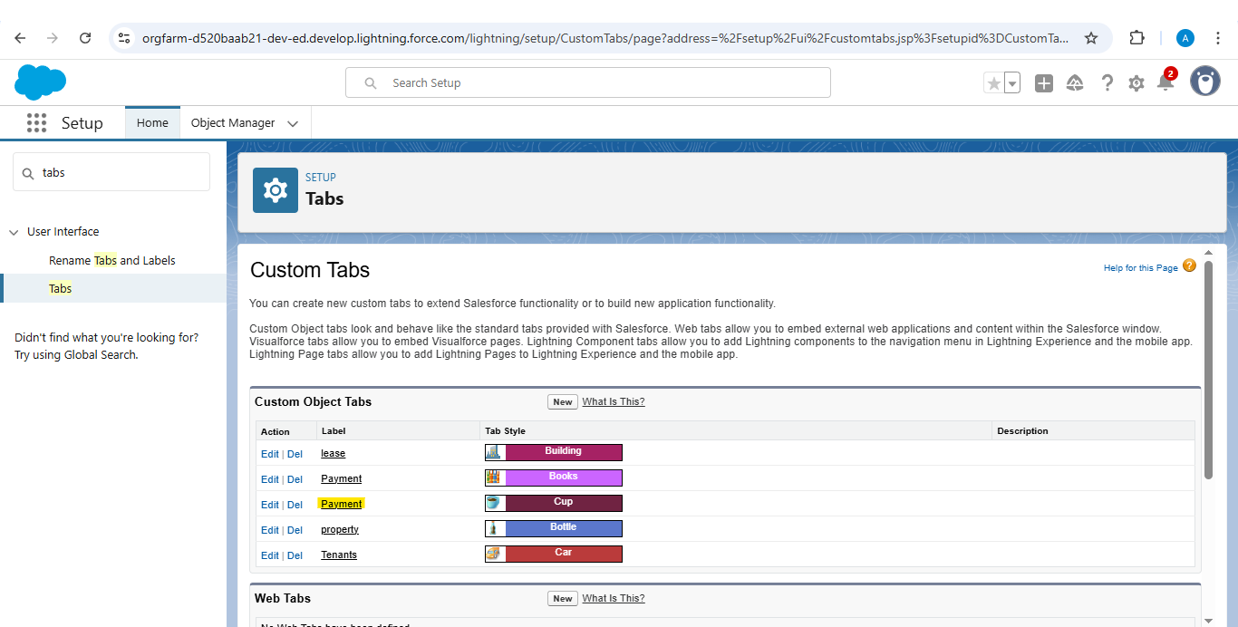

Lease Tabs

To create a Tab:( lease)

1. Go to setup page >>type Tabs in Quick Find bar >> click on tabs >> New (under custom object tab)
2. Select Object(lease), select the tab style you want and click next (keep the page as default) and then click next uncheck the include tab in Add to Custom App Page
3. Make sure that the Append tab to users’ existing personal customization is checked.
4. Click Save.

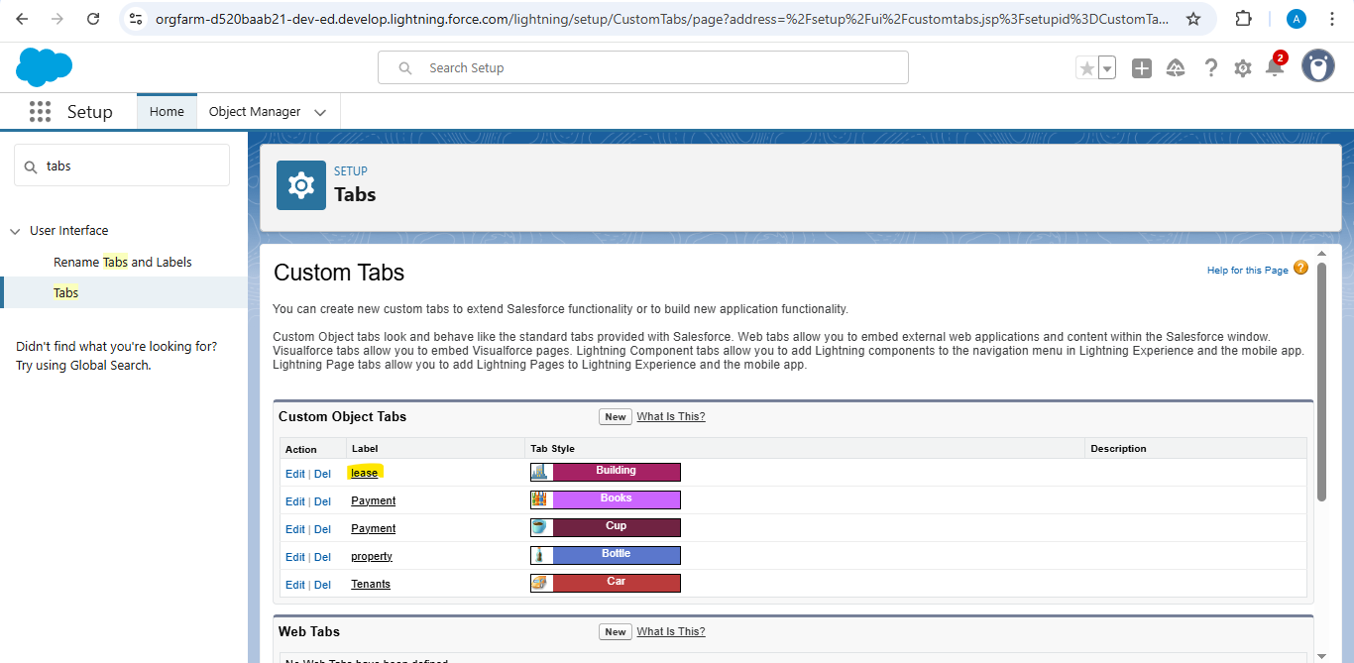

Tenant

To create a Tab:( tenant)

1. Go to setup page >>type Tabs in Quick Find bar >> click on tabs >> New (under custom object tab)
2. Select Object(tenant), select the tab style you want and click next (keep the page as default) and then click next uncheck the include tab in Add to Custom App Page
3. Make sure that the Append tab to users’ existing personal customization is checked.
4. Click Save.

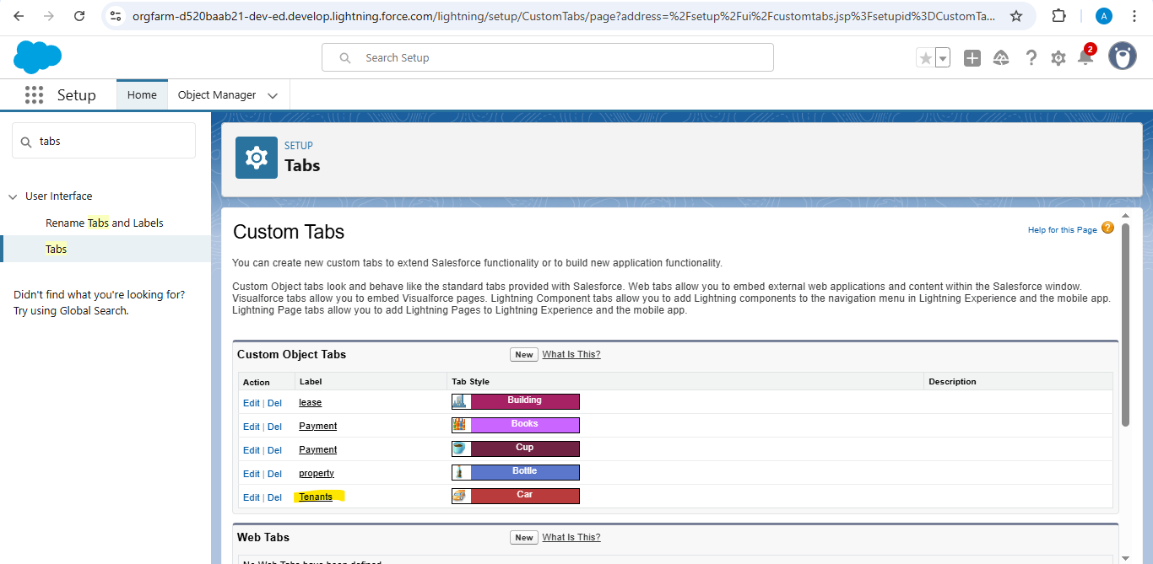

**Milestone 4:The Lightning Tabs**

***Activity: Create Lightning App***

To create a lightning app page:

1.Go to setup page >> search “app manager” in quick find >> select “app manager” >> click on New lightning App.

2. Fill the app name in app details and branding as follow

3.App Name : Lease Management Developer Name : This will auto populated Image : optional (if you want to give any image you can otherwise not mandatory) Primary colour hex value : keep this default.

4.Then click Next  >> (App option page)Set Navigation Style as Standard Navigation >> Next.

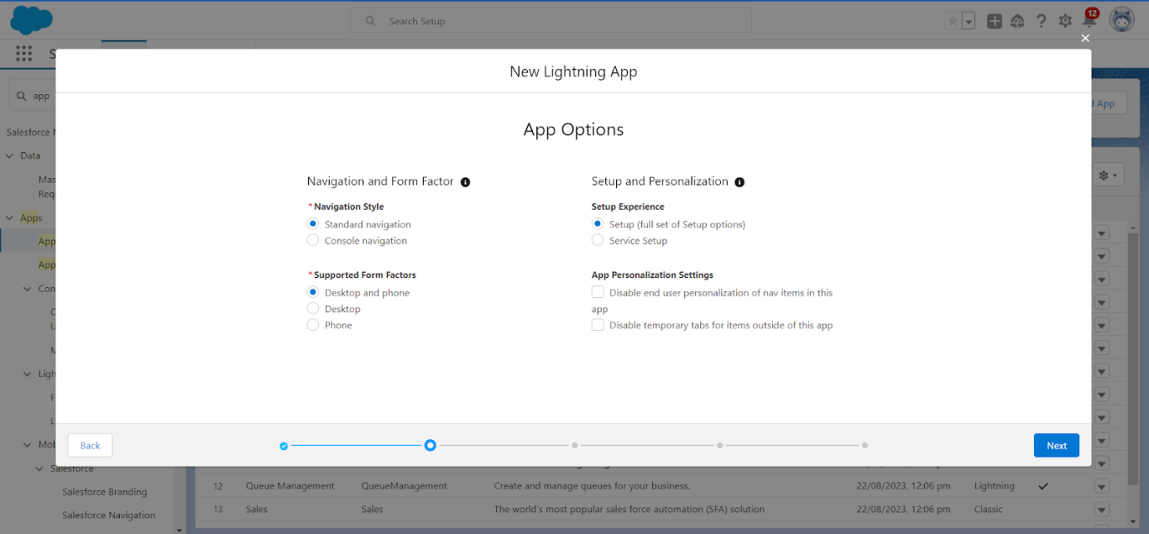

5.(Utility Items) keep it as default >> Next.

6. To Add Navigation Items:

7.Search for the item in the (Payment for tenant, Tenants, property, lease) from the search bar and move it using the arrow button >>Next>> Next.

8. To Add User Profiles:

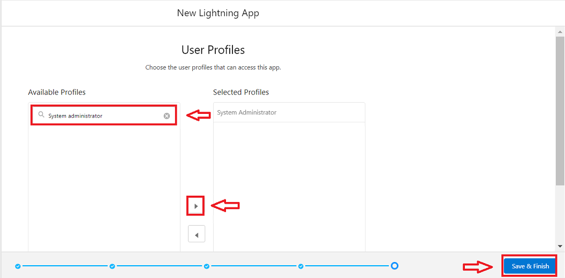

9.Search profiles (System administrator) in the search bar >>click on the arrow button >> save & finish.

**Milestone 5:Fields**

***Activity1 :Creation of Fields for the Property Object***

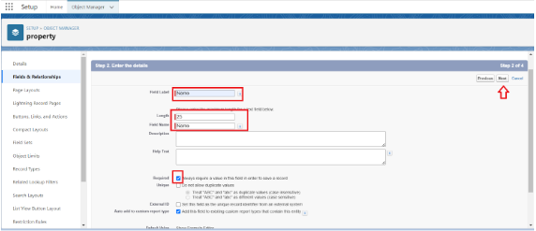

1.Go to Setup Page, click on the Object Manager type the object name Property in the search box and click on the object. Now click on the Fields and Relationships and click New .Select the Data Type for property object as ‘Text’.

2.Click on Next after selecting the Data Type .

3.Fill the below details in the ‘Enter the details’ Page:

* + - Field Label: Name
* Field Name : gets auto generated
* Length : 25
* Required :check box
* Click on Next >> Next >> Save and new.

To create another fields in an object:

1. Go to setup >> click on Object Manager >>type object name(property) in search bar >>click on the object.

2. Now click on “Fields & Relationships” >>New

3. Select Data type as a “Long Text” and Click on Next

4. Fill the Above as following:

* + Field Label : Address
  + Field Name : gets auto generated
  + Click on Next >> Next >> Save and new.

To create another fields in an object:

1.Go to Setup Page, click on the Object Manager type the object name Property in the search box and click on the object. Now click on the Fields and Relationships and click New .Select the Data Type for property object as ‘Long Text’.

2. Click on the next. Fill these in the page. Field Label as ‘Address’, Field Name gets auto generated, Click on Next>>Next>>Save.

To create another fields in an object:

1.Go to Setup Page, click on the Object Manager type the object name Property in the search box and click on the object. Now click on the Fields and Relationships and click New .Select the Data Type for property object as ‘picklist’.

2. Click on the Next. Type the following in the Box. Field Label as Type, Field Name gets auto generated, and Enter the values by clicking the Enter values, with each value separated by a value. values are:

1BHK

2BHK

3BHK

3.Click on Next>>Next>>Save and New.

To create another fields in an object:

1.Go to Setup Page, click on the Object Manager type the object name Property in the search box and click on the object. Now click on the ‘Fields and Relationships; and click New Select the Data Type for property object as ‘Text’.

2.Finally click on Next and enter the following:

* + Field Label: sqft
  + Field Name: gets auto generated
  + Length: 18
  + Click on Next>>Next>>Save.

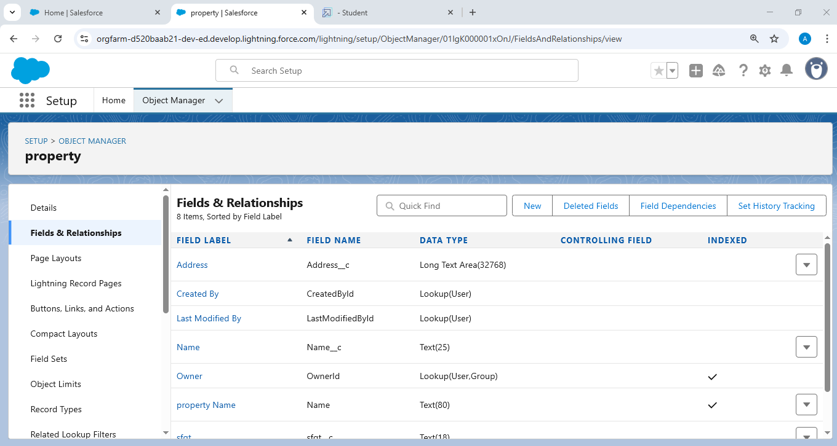

***Activity2: Creation of Fields for the Tenant Object:***

1.Go to Setup Page, click on the Object Manager type the object name ‘Tenant’ in the search box and click on the object. Now click on the ‘Fields and Relationships; and click New Select the Data Type as ‘Email’.

2.Click on Next. Give the Field label as Email, Field Name gets auto generated, then click on the Required Check Box. Click on the Next>>Next>>save an d New.

To create another fields in an object:

1.Go to Setup Page, click on the Object Manager type the object name ‘Tenant’ in the search box and click on the object. Now click on the ‘Fields and Relationships; and click New Select the Data Type as ‘phone’.

2.Click on Next. Give the Field label as ‘Phone’, Field Name gets auto generated, then Click on the Next>>Next>>save and New.

To create another fields in an object:

1.Go to Setup Page, click on the Object Manager type the object name ‘Tenant’ in the search box and click on the object. Now click on the ‘Fields and Relationships; and click New Select the Data Type as ‘picklist’.

2. Click on the Next. Type the following in the Box. Field Label as ‘status’, Field Name gets auto generated, and Enter the values by clicking the Enter values, with each value separated by a value. values are:

Stay

Leaving

3.Click on the Next>>Next>>Save

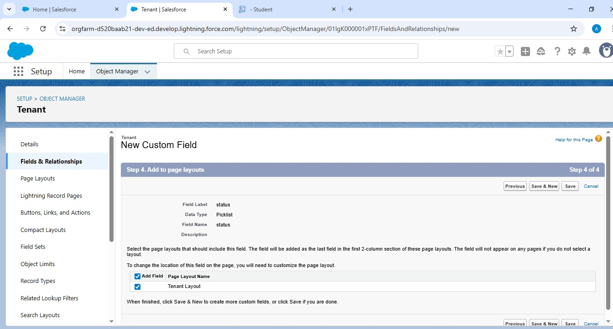

***Activity3: Creation of Fields for the Lease Object:***

1.Go to setup >> click on Object Manager >> type object name(Lease) in search bar >> click on the object.

2. Now click on “Fields & Relationships” >> New

3. Select Data type as a “Date” and Click on Next

4. Fill the Above as following:

* + - Field Label : start date
    - Field Name : gets auto generated
    - Click on Next >> Next >> Save and new.

To create another fields in an object:

1.Go to setup >> click on Object Manager >> type object name(Lease) in search bar >> click on the object.

2. Now click on “Fields & Relationships” >> New

3. Select Data type as a “Date” and Click on Next

4. Fill the Above as following:

* + - Field Label : End date
    - Field Name : gets auto generated
    - Click on Next >> Next >> Save and new.

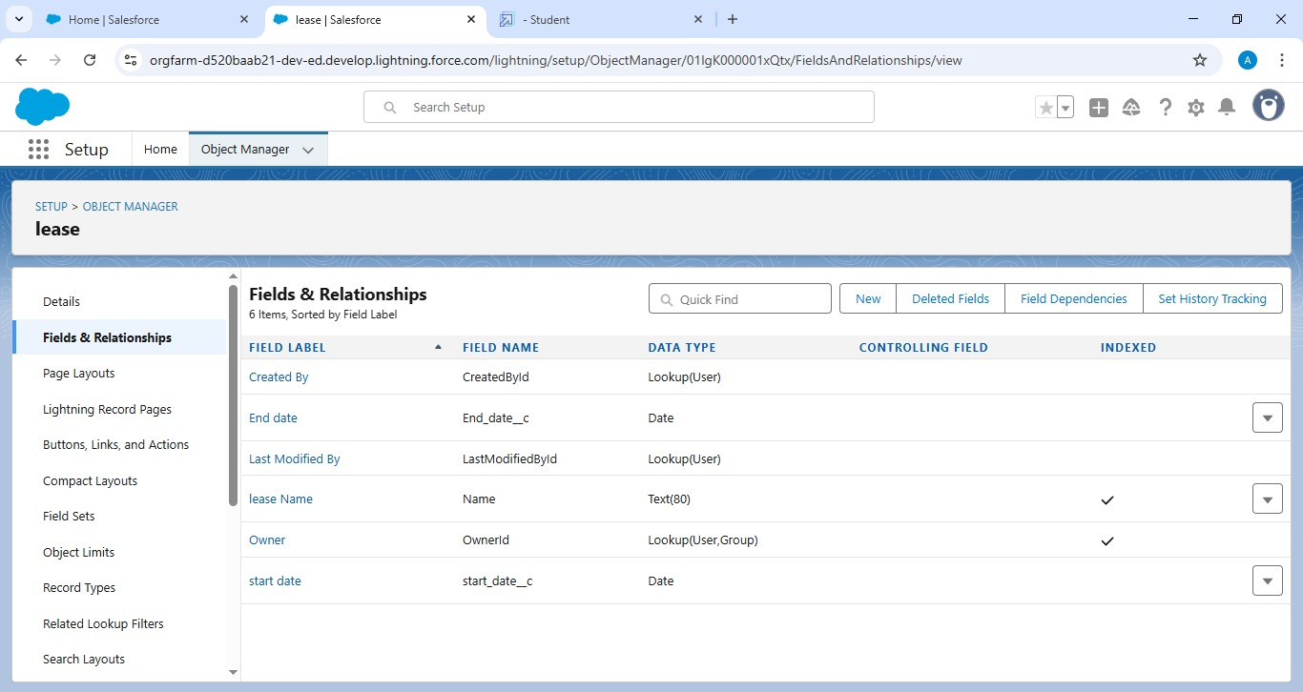

***Activity4: Creation of fields for the Payment for Tenant Object***

1.Go to setup >> click on Object Manager >> type object name(Payment for tenant) in search bar >> click on the object.

2. Now click on “Fields & Relationships” >> New

3. Select Data type as a “Date” and Click on Next

4. Fill the Above as following:

* Field Label : Payment date
* Field Name : gets auto generated
* Click on Next >> Next >> Save and new.

To create another fields in an object:

To create another fields in an object:

1.Go to setup >> click on Object Manager >> type object name(Payment for tenant) in search bar >> click on the object.

2. Now click on “Fields & Relationships” >> New

3. Select Data type as a “Number” and Click on Next

4. Fill the Above as following:

* Field Label : Amount
* Length: 18
* Field Name : gets auto generated
* Click on Next >> Next >> Save and new.

To create another fields in an object:

1.Go to setup >> click on Object Manager >> type object name(Payment for tenant) in search bar >> click on the object.

2. Now click on “Fields & Relationships” >> New

3. Select Data type as a “picklist” and Click on Next

4. Fill the Above as following:

* Field Label : check for payment
* Field Name : gets auto generated
* Enter values, with each value separated by a new line
* Enter these values  
  Paid  
  Not Paid
* Click on Next >> Next >> Save and new.

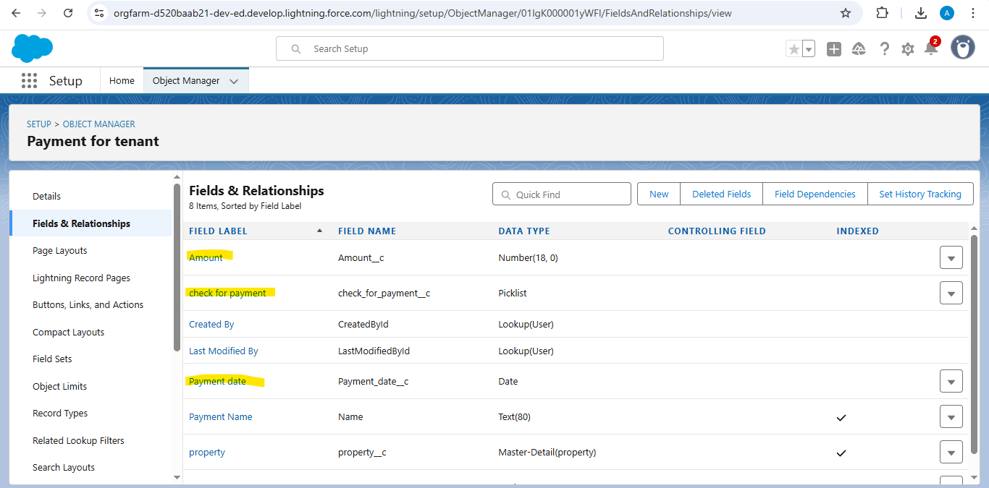

***Activity5 : Creation of Lookup Object***

Creation of Lookup Field on Lease Object :

1.Go to setup>> click on Object Manager >> type object name( Lease) in the search  bar >> click on the object.

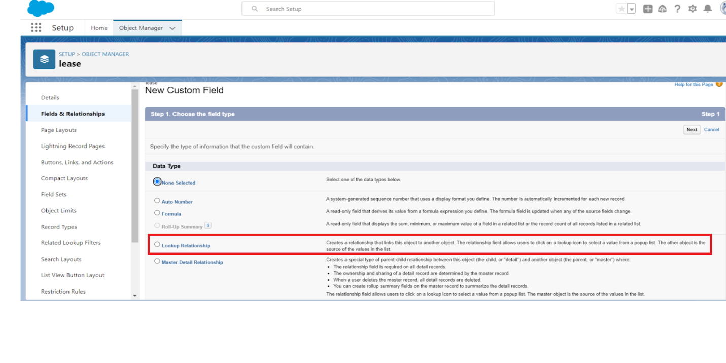

2.Now click on “Fields & Relationships” >> New

3.Select lookup relationship

4.Select the related object “ property” and click next.

5.Field Name : property

6.Field label : Auto generated

7.Next >> Next >> Save.

Creation of Lookup Field on Payment Object :

1. Go to setup >> click on Object Manager >> type object name( payment) in the search  bar >> click on the object.
2. Now click on “Fields & Relationships” >> New
3. Select lookup relationship
4. Select the related object “ Tenant” and click next.
5. Field Name : Tenant
6. Field label : Auto generated
7. Next >> Next >> Save.

Creation of Lookup Field on Payment for tenant  Object :

1. Go to setup>> click on Object Manager >> type object name( property) in the search  bar >> click on the object.
2. Now click on “Fields & Relationships” >> New
3. Select master detail relationship
4. Select the related object “ property” and click next.
5. Field Name : property
6. Field label : Auto generated
7. Next >> Next >> Save.

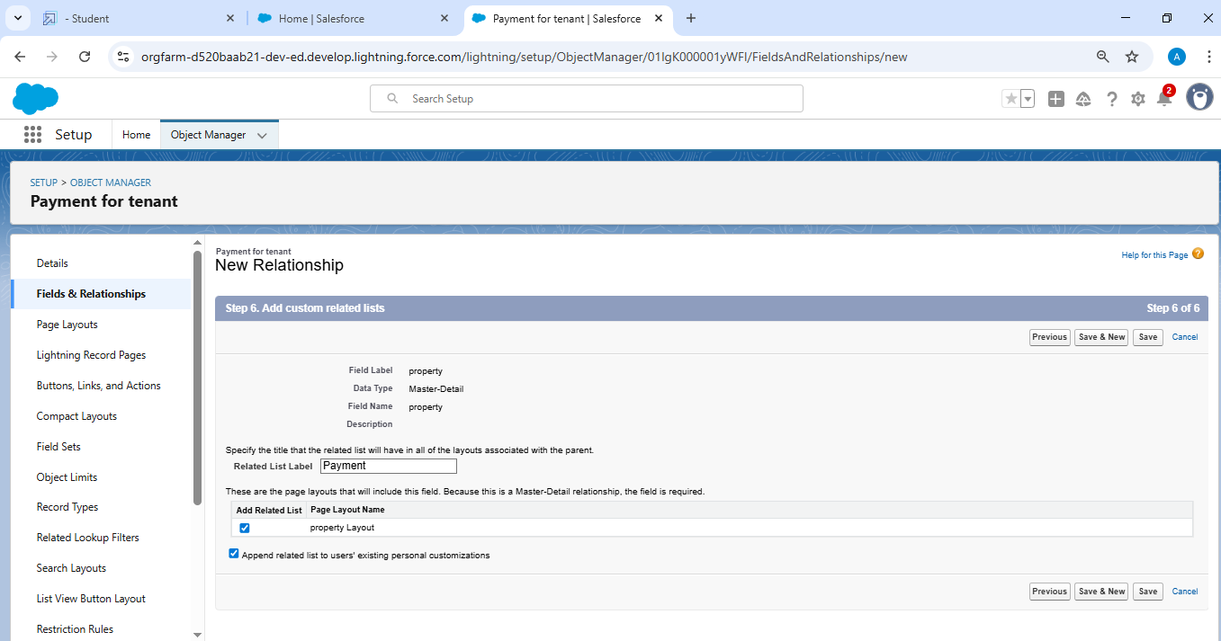

**Milestone 6: Validation Rule**

*Activity: To create a validation rule to an Lease Object*

1. Go to the setup page >> click on object manager >> From drop down click edit for  Lease object.
2. Click on the validation rule >> click New.

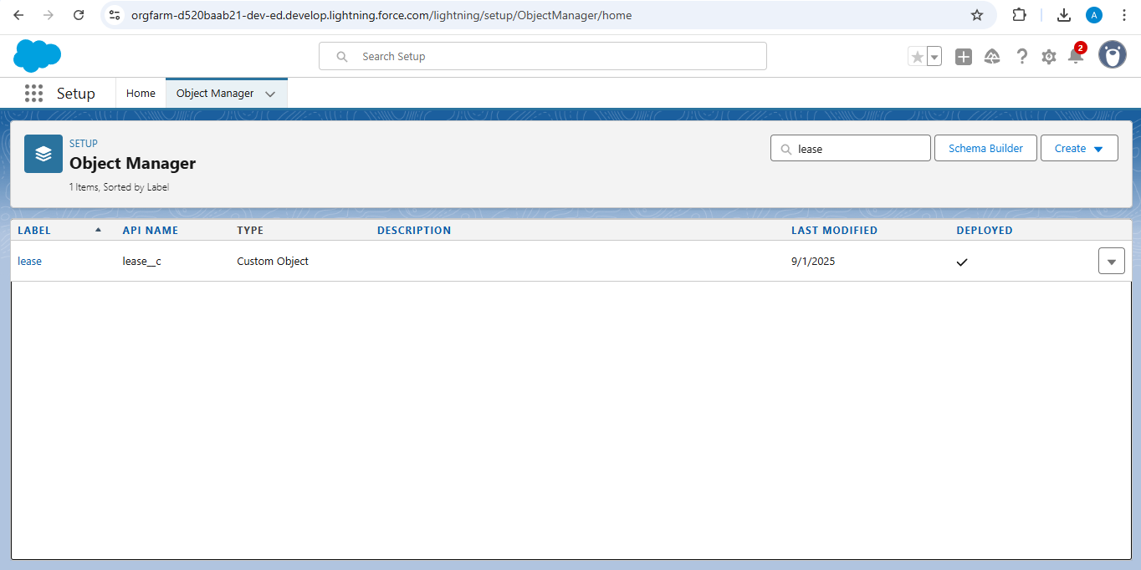

3.Enter the Rule name as “lease_end_date”.

4.Insert the Error Condition Formula as:  
End_date__c  >  start_date__c

5. Enter the Error Message as “Your End date must be greater than start date”, select the Error location as Field and select the field as “start date”, and click Save.

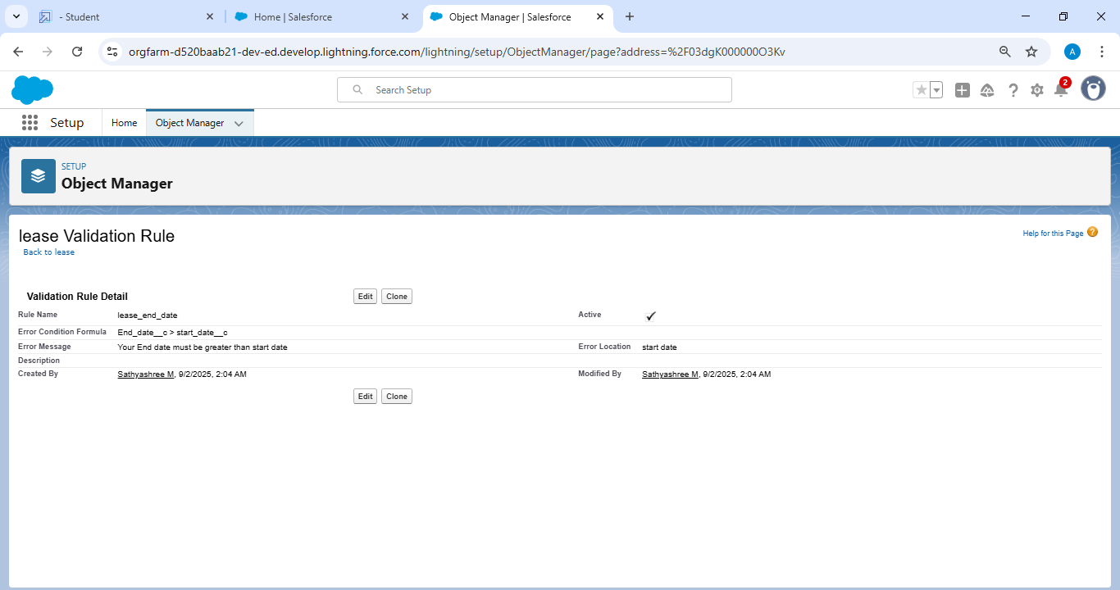

**Milestone 7: *Email Template***

***Activity 1 : To Create Email Template For Tenant Leaving***

To create Email Template:

1.Go to setup in quick find box enter email template >>

click on classic Email Template.

2.  Click on >> New Email Template===>Choose text

        Folder : Unfiled public Classic Email templates

Click on available for use

3.  Email Template Name is “tenant  leaving”

4. Template Unique Name : Auto populated

5.  Subject : ” request for approve the leave”

6. Email body :

Dear {!Tenant__c.CreatedBy},

Please approve my leave

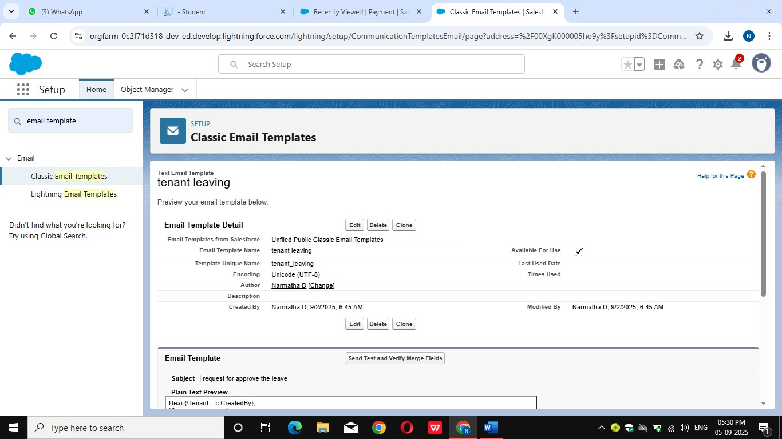

7. Save

***Activity 2 : Create Email Template For Leave Approved***

To create Email Template:

1.   Go to setup in quick find box enter email template >> click on . classic Email Template.

2.  Click on >> New Email Template===>Choose text

       Folder : Unfiled public Classic Email templates

Click on available for use

3.  Email Template Name is “Leave approved”

4. Template Unique Name : Auto populated

5.  Subject : ” Leave approved”

6. Email body :

dear{!Tenant__c.Name},

I hope this message finds you well. I am writing to inform you that I have received your email confirming the approval of my leave request. I would like to express my gratitude for considering and approving my time off.

your leave is approved. You can leave now

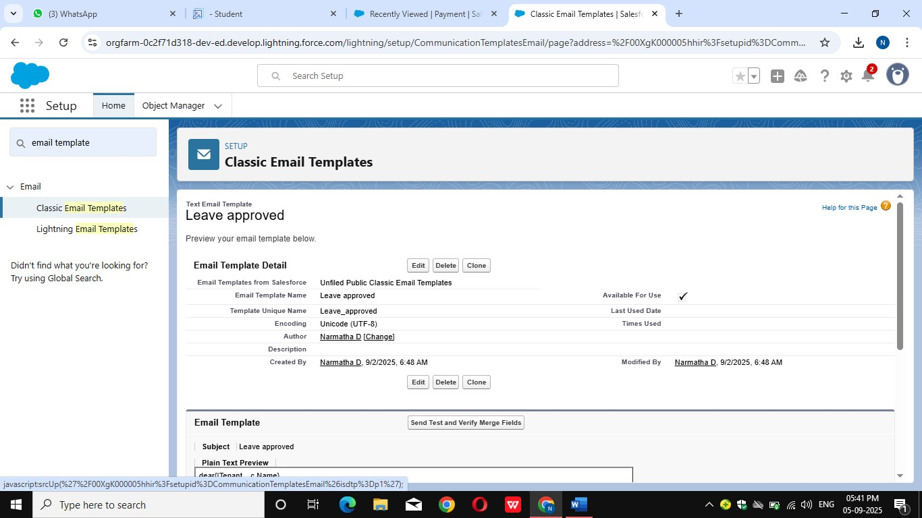

7. Save

***Activity 3 : Create Email Template For rejection for leave***

To create Email Template:

1.   Go to setup in quick find box enter email template >> click on . classic Email Template.

2.  Click on >>New Email Template===>Choose text

       Folder : Unfiled public Classic Email templates

Click on available for use

3.  Email Template Name is “Leave rejected”

4. Template Unique Name : Auto populated

5.  Subject : ” Leave rejected”

6. Email body :

Dear {!Tenant__c.Name},

I hope this email finds you well. Your contract has not ended. So we can't approve your leave

your leave has rejected

7. Save

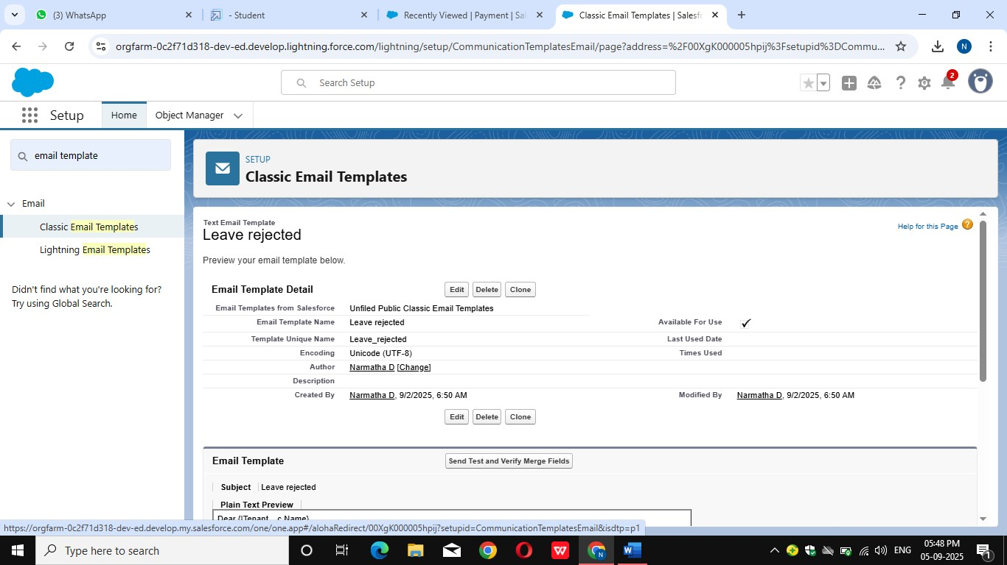

***Activity 4 : Create Email Template For Monthly payment***

To create Email Template:

1.   Go to setup in quick find box enter email template >> click on . classic Email Template.

2.  Click on >> New Email Template===>Choose text

       Folder : Unfiled public Classic Email templates

Click on available for use

3.  Email Template Name is “Tenant Email”

4. Template Unique Name : Auto populated

5.  Subject : ” Urgent: Monthly Rent Payment Reminder”

6. Email body :

Dear {!Tenant__c.Name},

I trust this email finds you well. We appreciate your continued tenancy at our property and I hope you have been comfortable in your residence.

This communication is a friendly reminder regarding your monthly rent payment, which is currently outstanding. As outlined in our rental agreement, the payment is due . To ensure the smooth operation of our property management and to avoid any inconvenience, we kindly request you to settle the payment at your earliest convenience.

7. Save

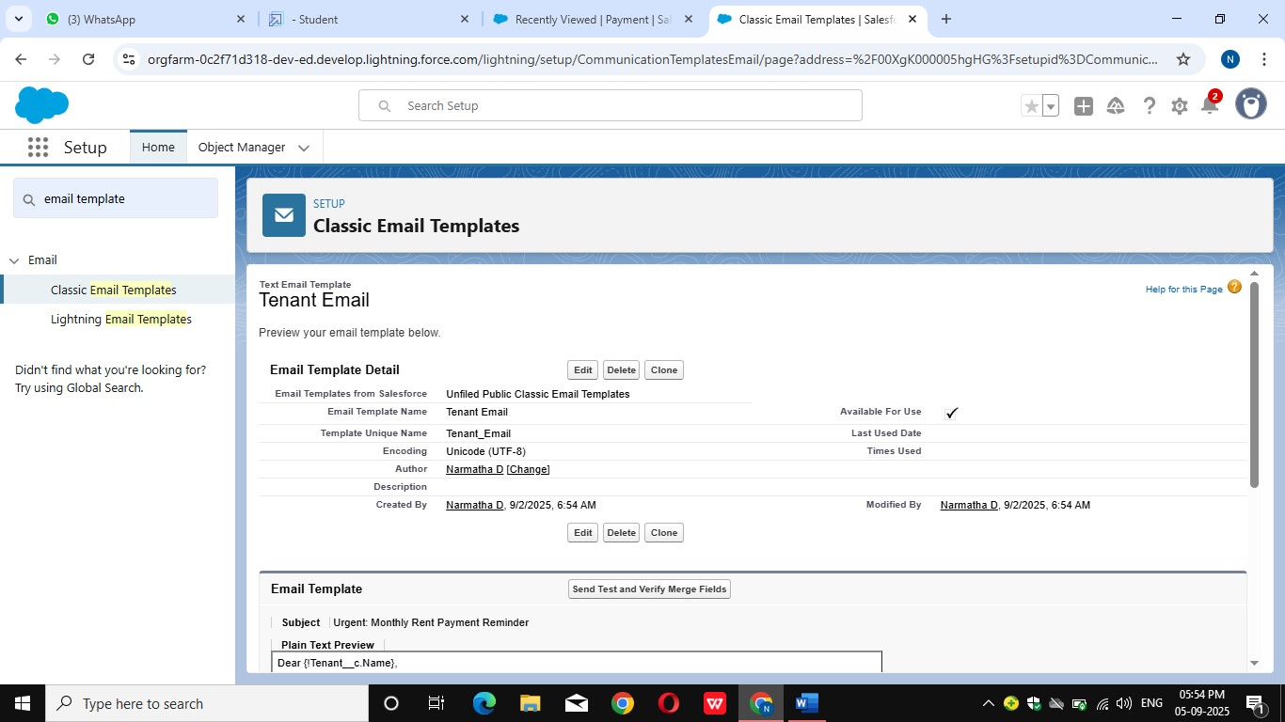

***Activity 5 : Create Email Template For successful payment***

To create Email Template:

1.  Go to setup in quick find box enter email template >> click on . classic Email Template.

2.  Click on >> New Email Template===>Choose text

       Folder : Unfiled public Classic Email templates

Click on available for use

3.  Email Template Name is “tenant payment”

4. Template Unique Name : Auto populated

5.  Subject : ” Confirmation of Successful Monthly Payment”

6. Email body :

Dear {!Tenant__c.Email__c},

We hope this email finds you well. We are writing to inform you that we have successfully received your monthly payment. Thank you for your prompt and diligent payment.

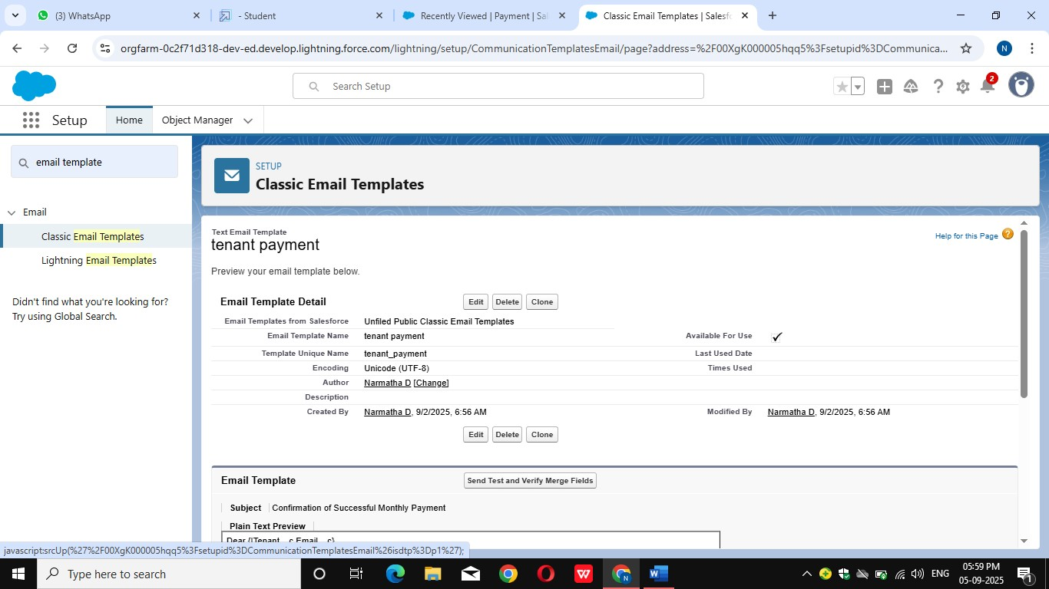

7. Save

**Milestone 8: Approval Process**

***Activity 1 : Create Approval Process For check for vacant***

To create fields in an object:

1.Go to setup >> Approval Processes in quick find bar>>click on it.

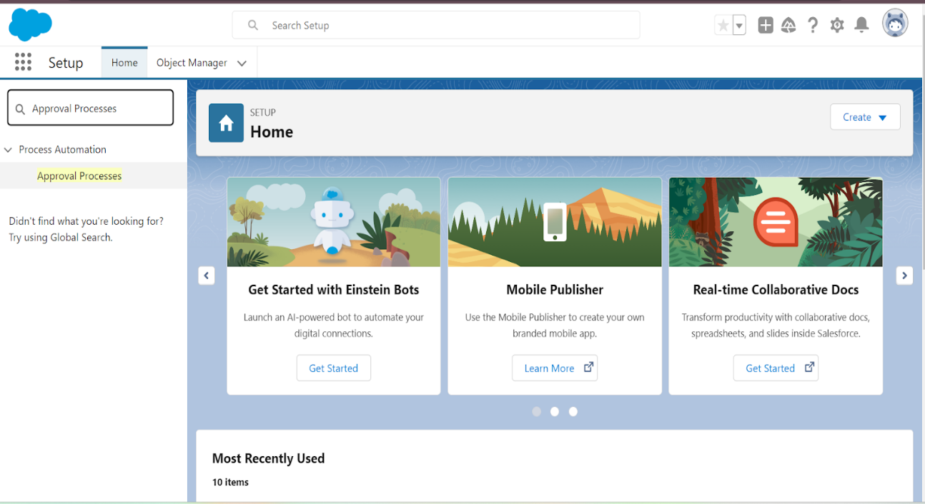

2.Manage Approval Process For >> “Tenant” from the drop down.

3.Click on “Create New Approval  Process” >> Use standard setup . wizard.

4. Process Name “check for vacant” >> Click Next.

5. Field “Tenant:status” >> Operator : Not equals , Value >> Click . on the lookup filter   icon and select “Leaving”.

6.Click insert field,then click Next.

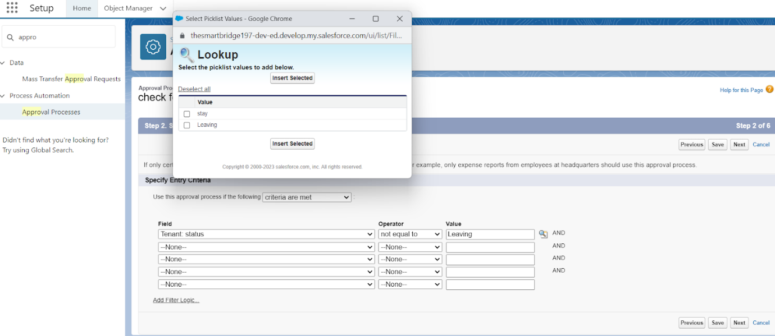

7. Next Automated Approver determined by “None” from the drop down.

8. Select the “Administrators ONLY can edit records during the approval  process”.Then Next.

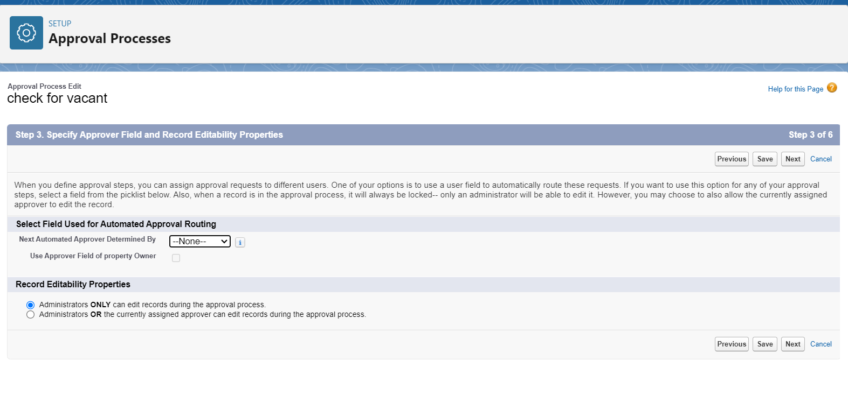

9. Click on next leave the email template click on next

10.From the available fields select >> Tenant Name, and then add >>Add it to the selected.Then Next.

* Make sure Display approver history is checked.
* And under security settings check the “Allow approvers to access the approval page only from within the Salesforce application. (Recommended)” option.

11.Submitter type Search>>Owner, Allowed Submitters>>Property Owner.Then Next.

* Then click save.

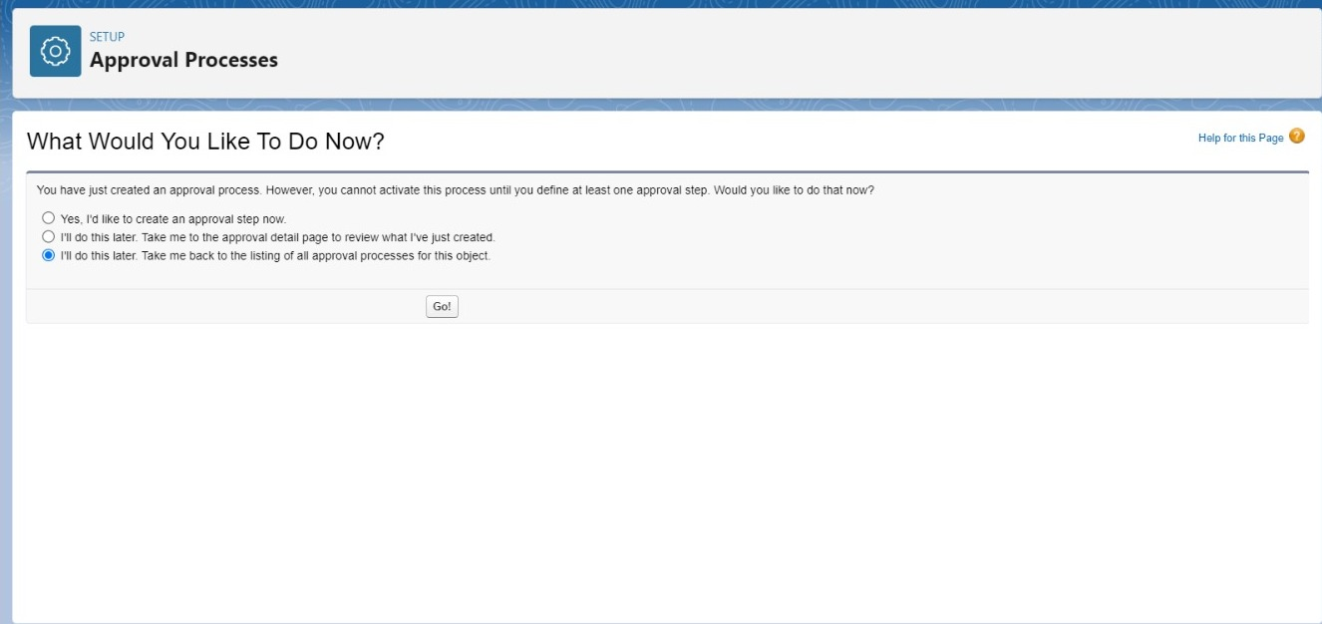

* Click on “i’ll do this later. Take me back to the listing of all approval process for this object”
* Click go

***Activity 2 : Initial Submission Action:***

1. Under initial submission action click on add new and then select email alert.

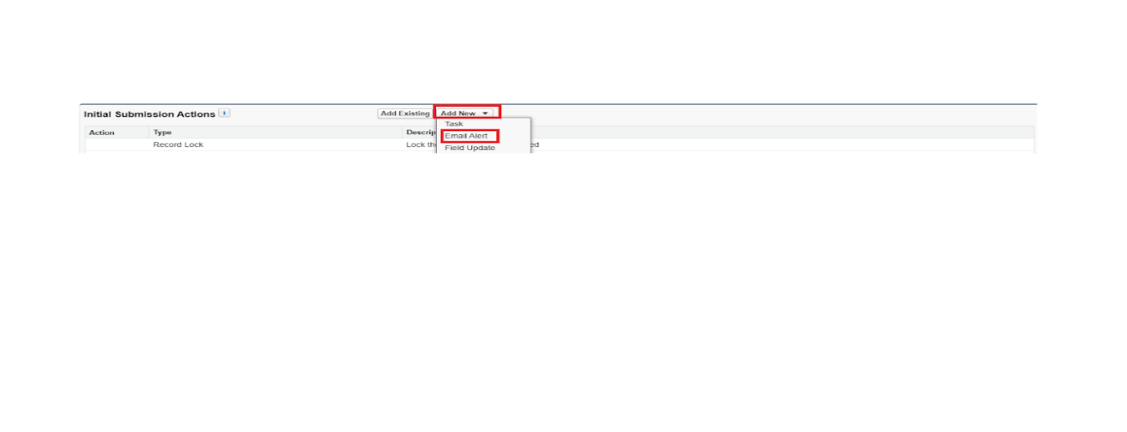

2.Description: “please approve my leave”.

3.unique name : auto populated

4.Email template : tenant leaving

5. Recipient type : Email field

6. Available Recipients : Email field : Email

7. From Email address : Current user’s email

8. Click save

***Activity 3 : Final Approval Action***

1. Under Final approval action click o n new and then select email alert.
2. Description: “Tenant leaving”.
3. unique name : auto populated
4. Email template : Leave approved
5. Recipient type : Email field
6. Available Recipients : Email field : Email
7. From Email address : Current user’s email
8. Click save

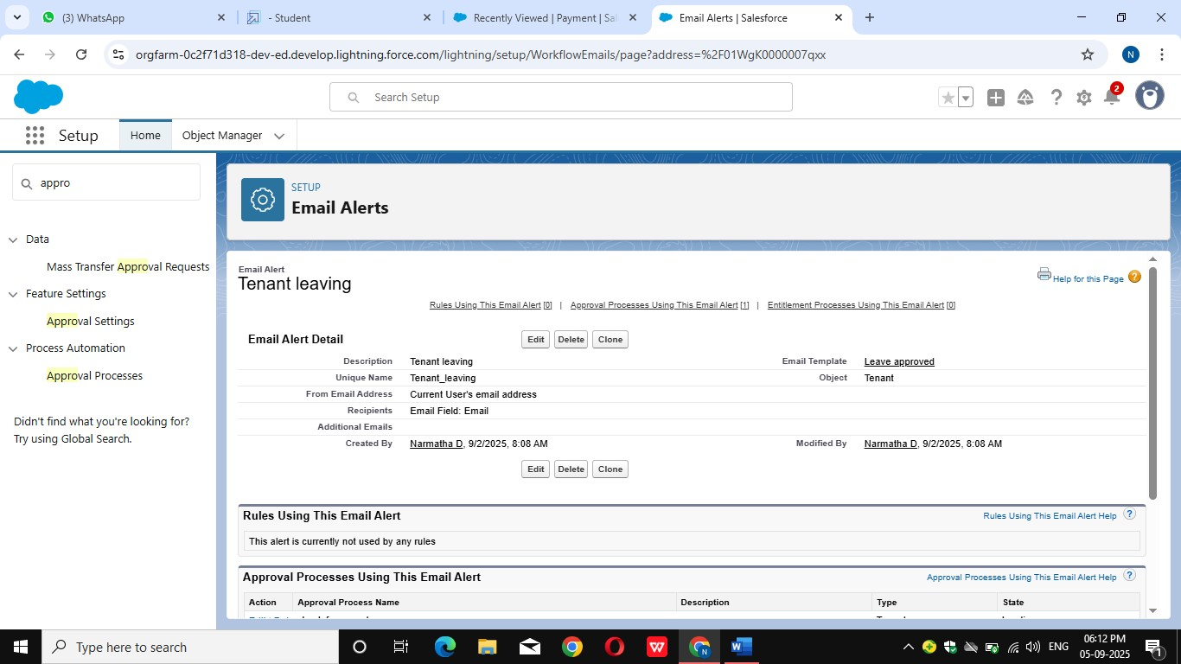

***Activity 4 : Final Rejection Action***

1. Under final rejection action click on add new and then select email alert.

2.Description: “your request for leave is rejected”.

3.unique name : auto populated

4.Email template : leave rejected

5. Recipient type : Email field

6. Available Recipients : Email field : Email

7. From Email address : Current user’s email

8. Click save

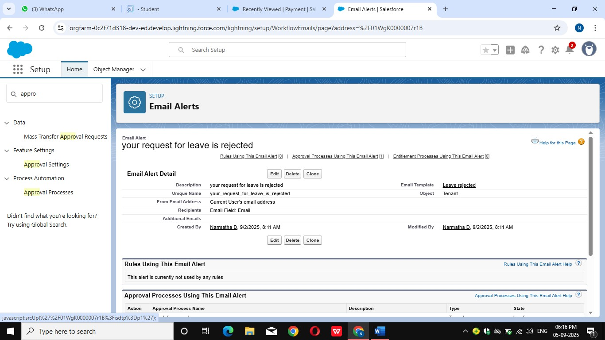

**Milestone 9: Apex Trigger**

***Activity 1 : Create an Apex Trigger***

1. To create a new Apex Class fol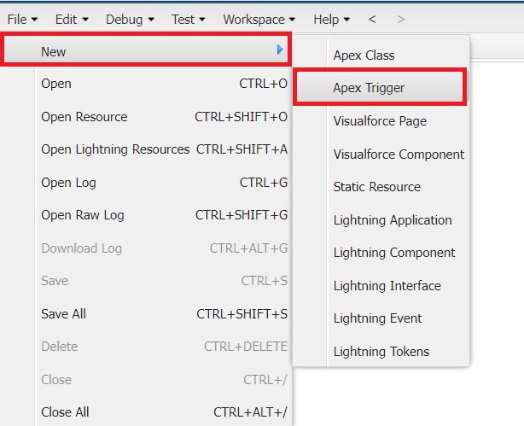
2. low the below steps:
3. Click on the file >> New ? Apex Class.
4. Give the Apex Trigger name as “test”, and select “Tenant__c” from the dropdown for sObject.

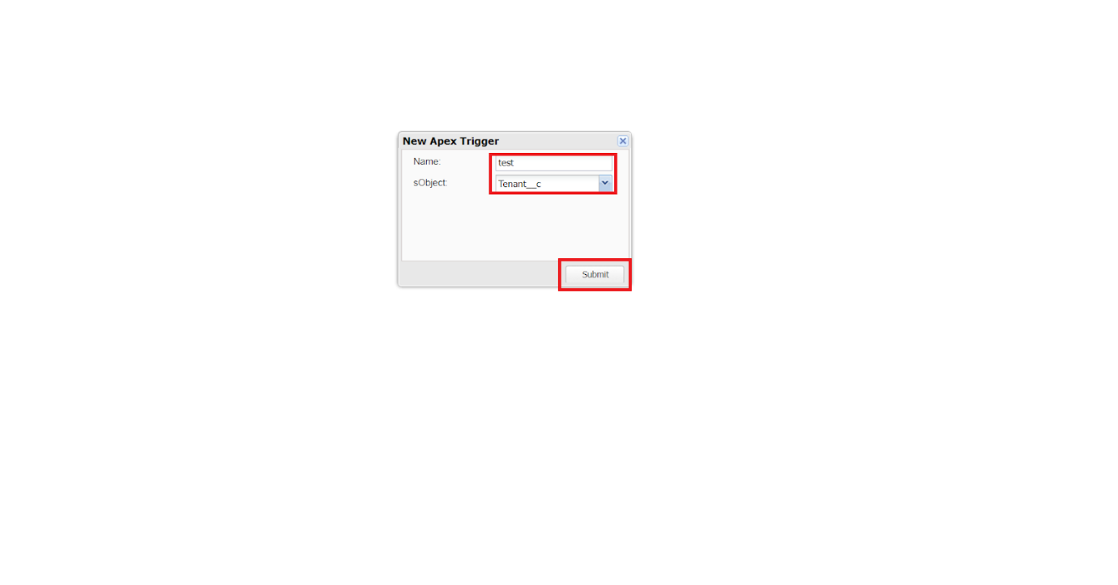

1. Click Submit.
2. Now write the code logic here

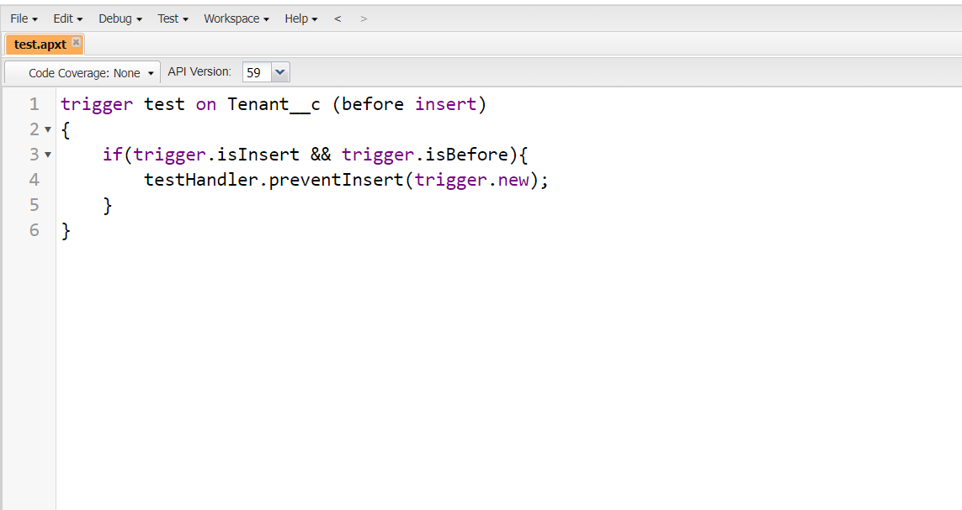

Trigger Code:

trigger test on Tenant__c (before insert)

{

    if(trigger.isInsert && trigger.isBefore){

        testHandler.preventInsert(trigger.new);

    }

}

***Activity 2 : Create an Apex Handler class***

1.To create a new Apex Class follow the below steps:

Click on the file >> New >>Apex Class.

2. Enter class name as testHandler.

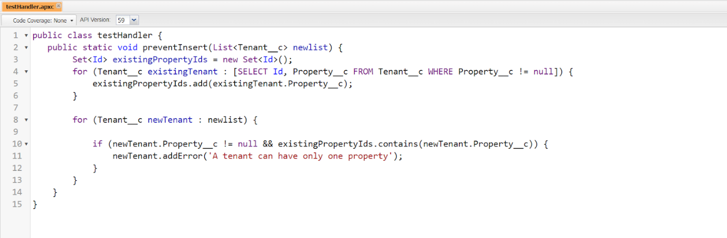

Apex logic:

public class testHandler {

   public static void preventInsert(List<Tenant__c> newlist) {

        Set<Id> existingPropertyIds = new Set<Id>();

        for (Tenant__c existingTenant : [SELECT Id, Property__c FROM Tenant__c WHERE Property__c != null]) {

            existingPropertyIds.add(existingTenant.Property__c);

        }

        for (Tenant__c newTenant : newlist) {

            if (newTenant.Property__c != null && existingPropertyIds.contains(newTenant.Property__c)) {

                newTenant.addError('A tenant can have only one property');

            }

        }

    }

}

***Activity 3 : Testing the Trigger***

Try to create new tenant with the existing property then it shows the error

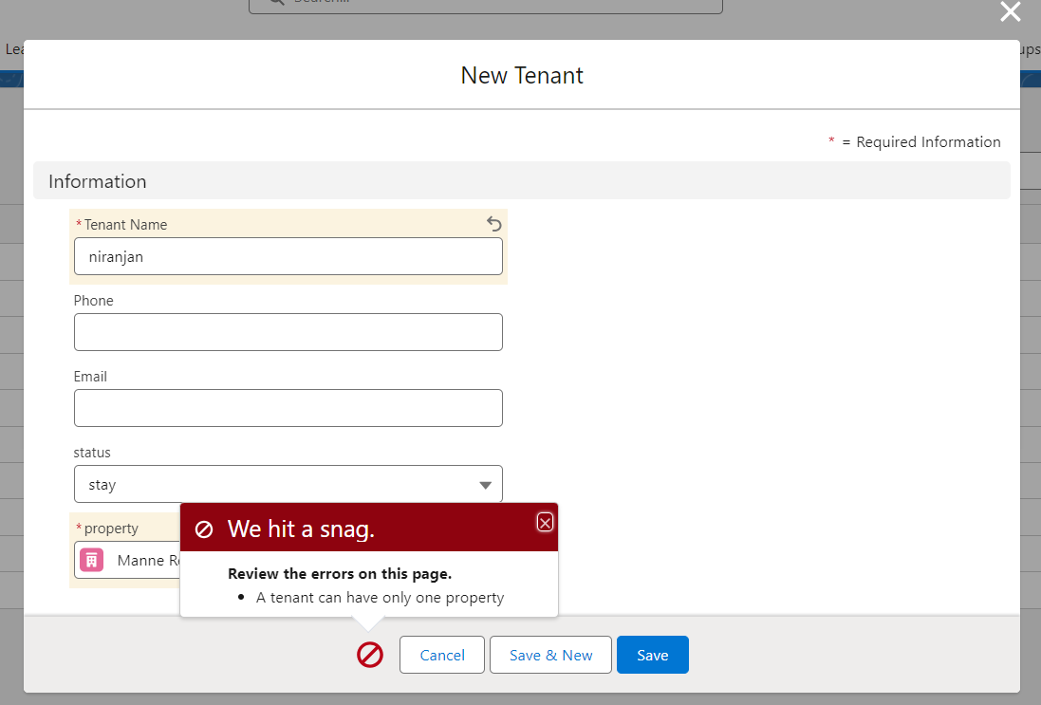

**Milestone 10:** **FLOWS**

***Activity 1 : Create Flow for monthly payment***

1. Go to setup >> type Flow in quick find box >>  Click on the Flow and Select the New Flow.
2. Select the record Triggered flow.Click on create.

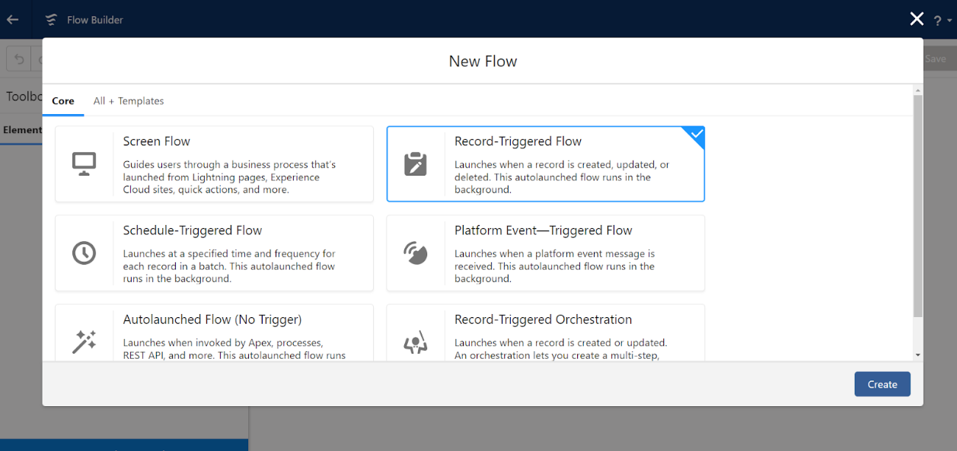

3. Under Object select ”Payment for tenant”. Click on  A record is updated.

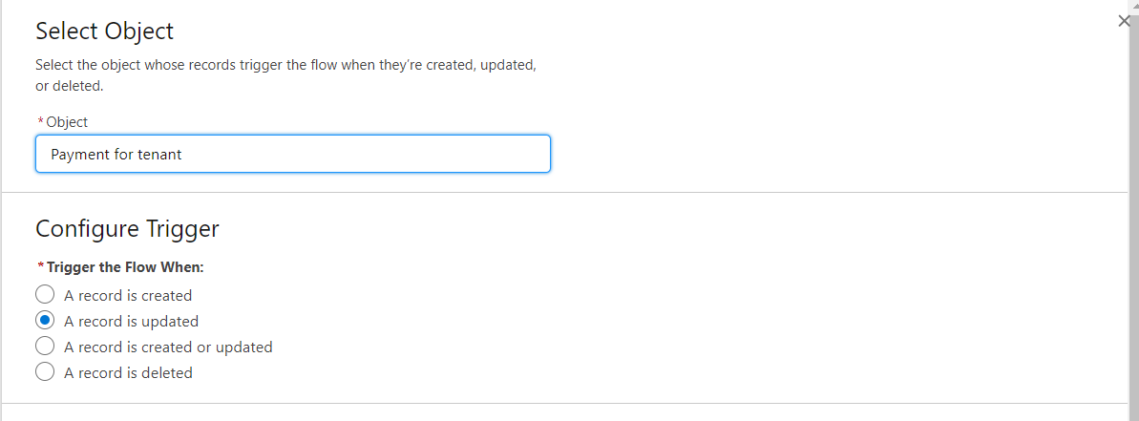

4. Set Entry Conditions

Under Condition Requirements

All Conditions are met

|  |  |  |
| --- | --- | --- |
| **Field**: check_for_payment__c | **Operator**: Equals | **Value** : paid |

5. Click on : Every time a record is updated and meets the condition requirements

6. Click on : Actions and related records,done

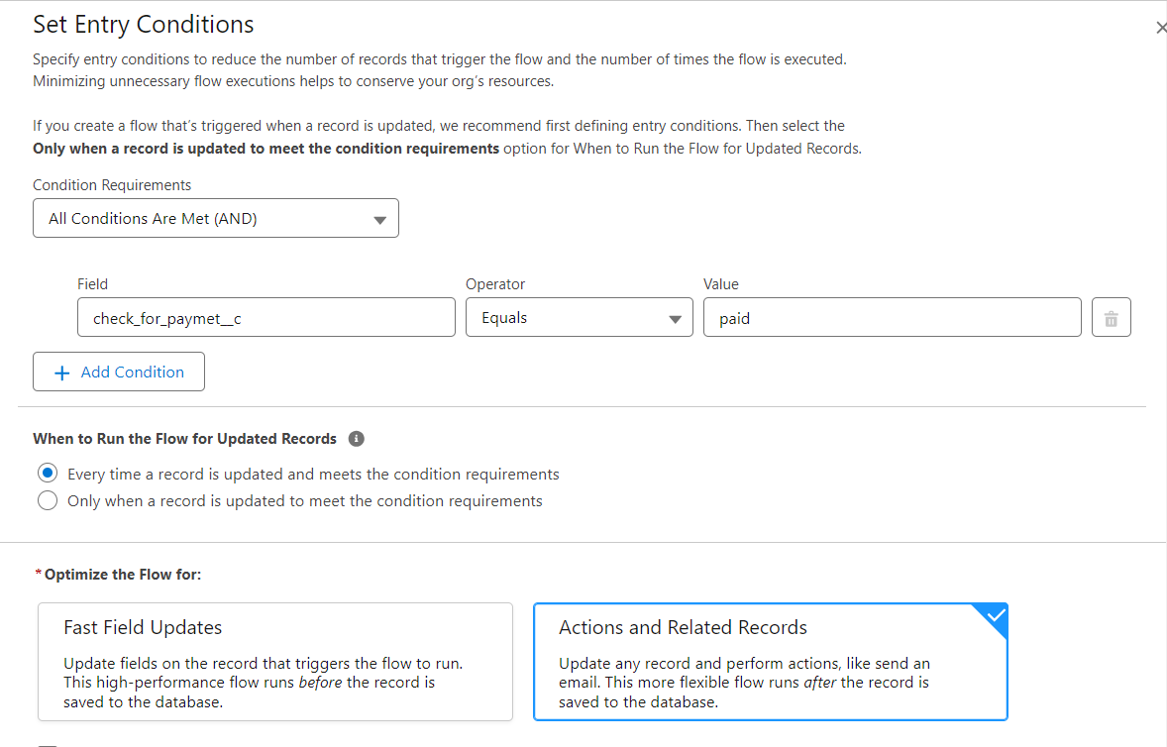

7. Under record trigger flow click on “+” icon and select action

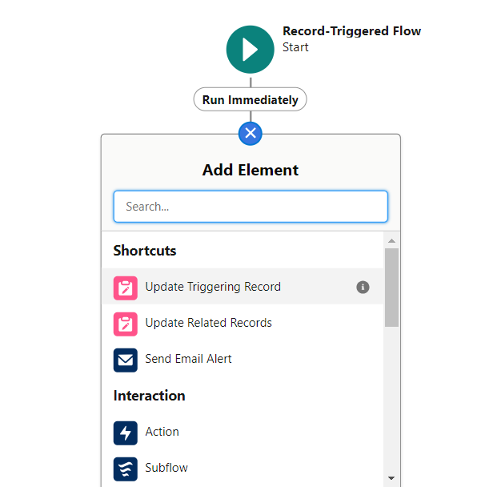

In action search for send email then click on send email (check below image)

8. Label : send email

API Name : send_email

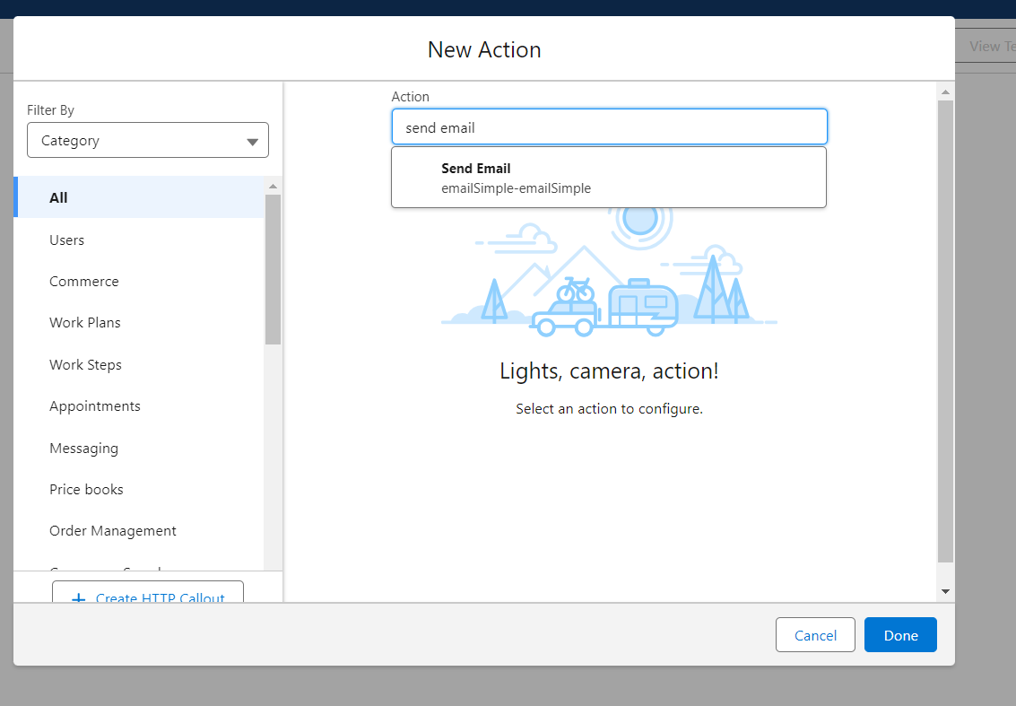

9. Label : send email

10. API Name : send_email

11. Enable Body

12. Click on new resource

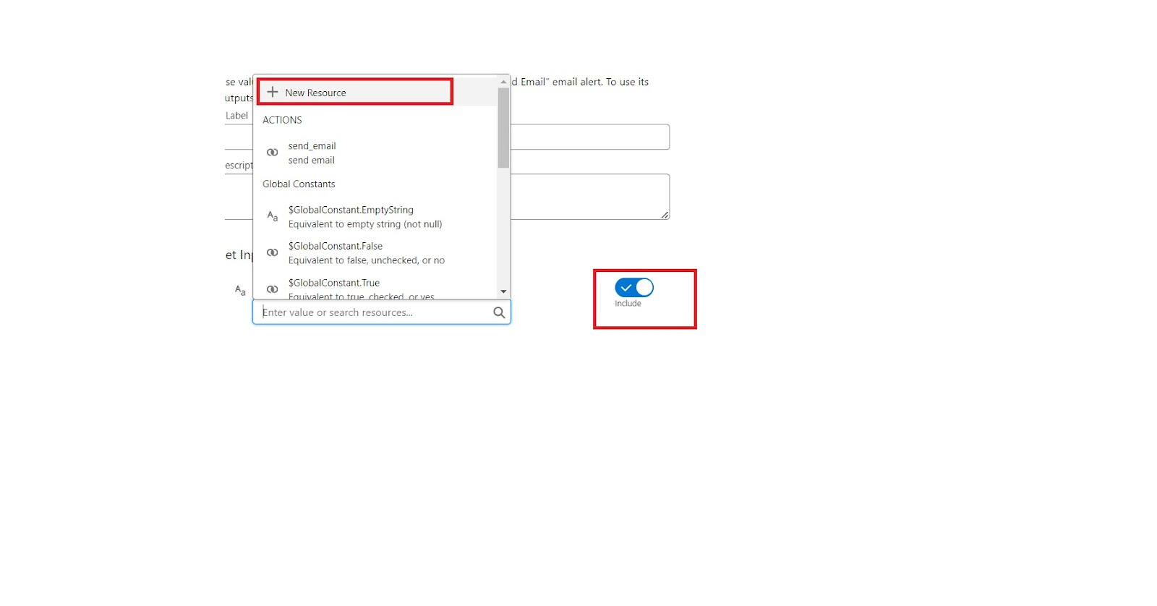

Under resource type select “Text Template”

API Name : emailbody

Under body:                     (paste the below text)

Dear {!$Record.Tenant__r.Name},

We hope this email finds you well. We are writing to inform you that we have successfully received your monthly payment. Thank you for your prompt and diligent payment.

14. Click Done.

15. Enable recipient Address List

Paste this ?{!$Record.Tenant__r.Email__c}

16. Click Done

17. Enable subject

Pate this >> Confirmation of Successful Monthly Payment

18. Click on save

Flow label : monthly payment

Flow API Name : monthly_payment

Click on activate

**Milestone 11: Schedule class :**

***Activity 1 : Create an Apex Class***

1. To create a new Apex Class follow the below steps:

Click on the file >> New >> Apex Class.

2. Enter class name as MonthlyEmailScheduler.

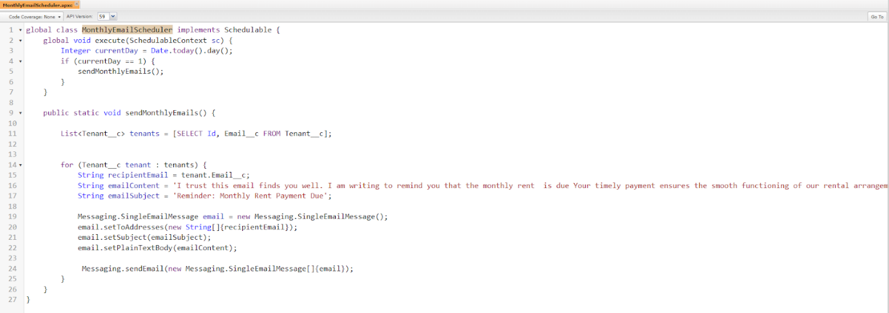

Apex logic:

global class MonthlyEmailScheduler implements Schedulable {

    global void execute(SchedulableContext sc) {

        Integer currentDay = Date.today().day();

        if (currentDay == 1) {

            sendMonthlyEmails();

        }

    }

    public static void sendMonthlyEmails() {

        List<Tenant__c> tenants = [SELECT Id, Email__c FROM Tenant__c];

        for (Tenant__c tenant : tenants) {

            String recipientEmail = tenant.Email__c;

            String emailContent = 'I trust this email finds you well. I am writing to remind you that the monthly rent  is due Your timely payment ensures the smooth functioning of our rental arrangement and helps maintain a positive living environment for all.';

            String emailSubject = 'Reminder: Monthly Rent Payment Due';

            Messaging.SingleEmailMessage email = new Messaging.SingleEmailMessage();

            email.setToAddresses(new String[]{recipientEmail});

            email.setSubject(emailSubject);

            email.setPlainTextBody(emailContent);

             Messaging.sendEmail(new Messaging.SingleEmailMessage[]{email});

        }

    }

}

Save the code.

***Activity 1 : Schedule Apex class***

1. Enter Apex class in quick find box
2. Select schedule Apex

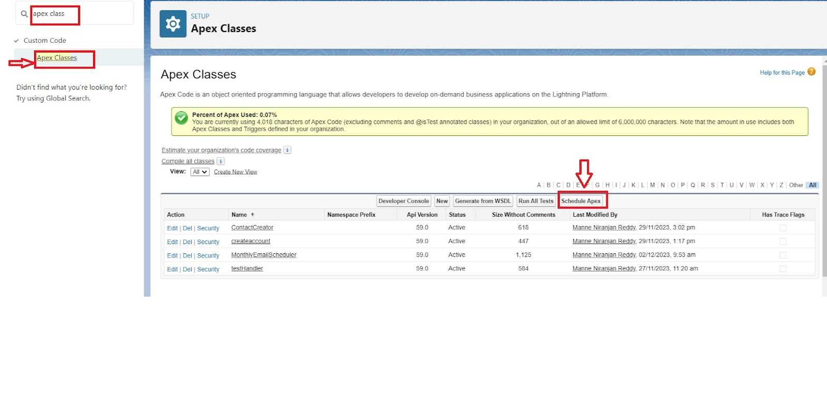

1. Enter job Name : MonthlyEmailScheduler
2. Apex class : MonthlyEmailScheduler
3. Frequency : Monthly===>select on day 1
4. Start date : 04/12/2023
5. End date : 04/01/2024
6. Preferred start time : 09:00 am
7. save

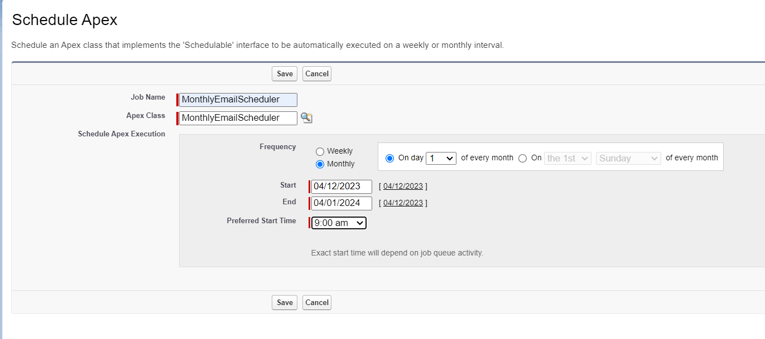

Testing the approval process

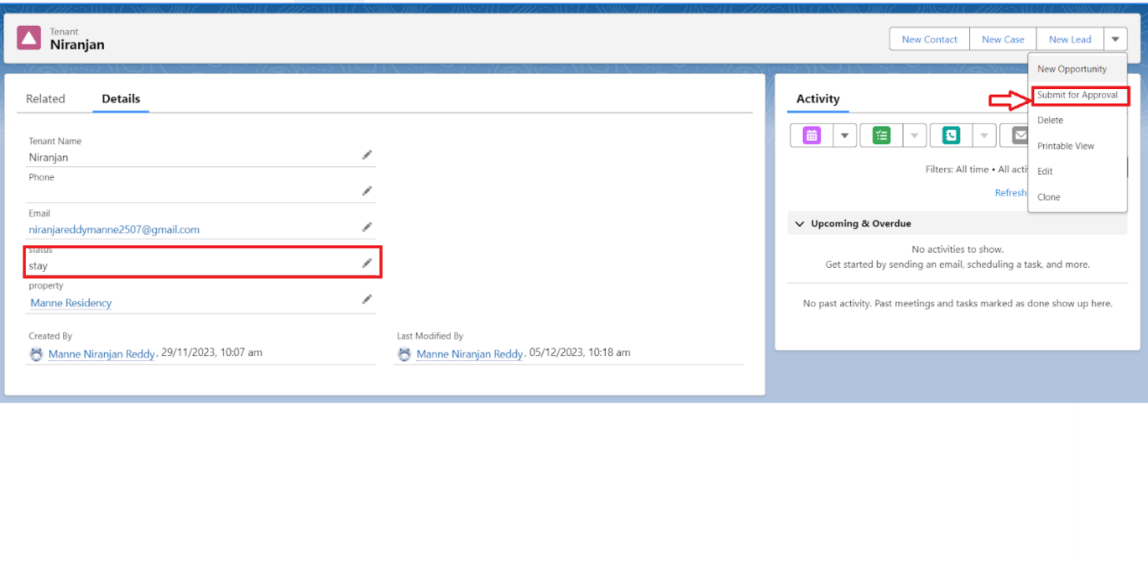Click on that notification

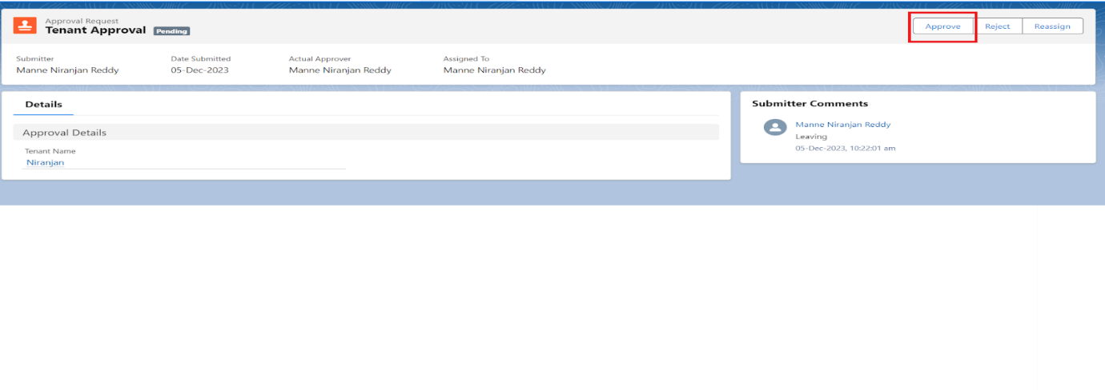click on approve

Give any comment and submit

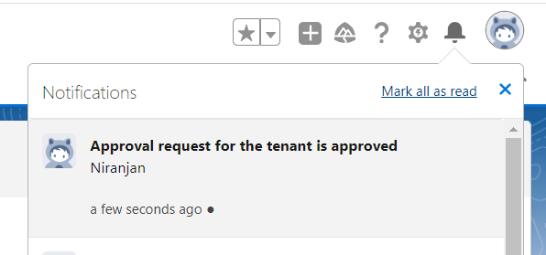You will find notification like this and you will get an email check  
Note: similarly do for reject also you will get mail and notification